**A PROJECT REPORT**

ON

DOOR UNLOCKING SYSTEM BASED ON FACIAL RECOGNITION USING MACHINE LEARNING

Submitted in partial fulfilment of the requirement for the Award of the Degree of

**BACHELOR OF ENGINEERING**

In

**ELECTRICAL AND ELECTRONICS ENGINEERING**

By

**B. ABHILASH (160117734072)**

**R. POOJITH (160117734096)**

**MOHAMMED AMAAN (160117734090)**

Under the guidance of

**Dr. K. KRISHNAVENI**

**Professor, Dept. of. EEE, CBIT(A),**

**Hyderabad.**



**DEPARTMENT OF ELECTRICAL AND ELECTRONICS CHAITANYA BHARATHI INSTITUTE OF TECHNOLOGY (A)**

**(Affiliated to Osmania University; Accredited by NBA (AICTE) and NAAC (UGC), ISO Certified 9001:2015), Kokapet (V), GANDIPET (M), HYDERABAD – 500075**

**Website:** [**www.cbit.ac.in**](http://www.cbit.ac.in/) **2020-2021**

### 

**DECLARATION**

We declare that the project work **“DOOR UNLOCKING SYSTEM BASED ON FACIAL RECOGNITION USING ML”** submitted in the department of Electrical and Electronics Engineering (EEE), Chaitanya Bharathi Institute of Technology, Hyderabad in fulfilment of degree for the award of **Bachelor of Engineering** is a bonafide work done by us, which was carried under the supervision of “Dr. K. KRISHNAVENI”.

Also, we declare that the matter embedded in this report has not been submitted by us in full or partial thereof for the award of any degree/diploma of any other institution or University previously.

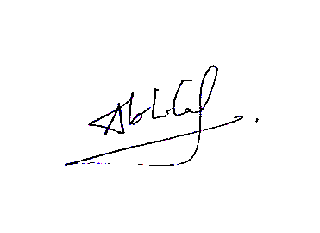

**BUDHARAPU ABHILASH**

(160117734072)

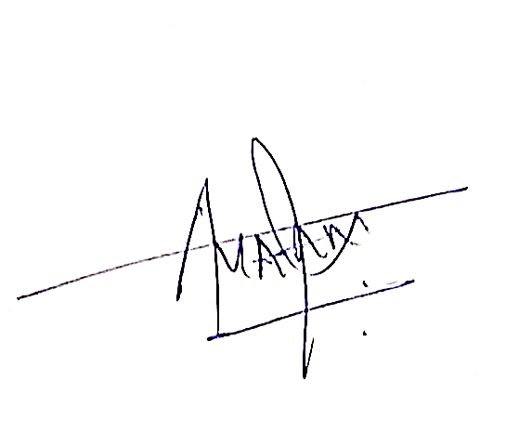**MOHAMMED AMAAN**

(160117734090)

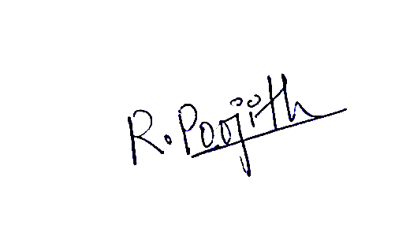**RAMAGIRI POOJITH**

(160117734096)

STATION: HYDERABAD DATE: 09/05/2021



**Dr. K. KRISHNAVENI**

Professor Dept. of EEE

CBIT, Hyderabad

CBIT, HYDERABAD



**DEPARTMENT OF ELECTRICAL AND ELECTRONICS CHAITANYA BHARATHI INSTITUTE OF TECHNOLOGY (AUTONOMOUS) HYDERABAD – 500075**

**CERTIFICATE**

This is to certify the project work entitled **“DOOR UNLOCKING SYSTEM BASED ON FACIAL RECOGNITION USING MACHINE LEARNING”** is a bonafide work carried out by

**B. ABHILASH (160117734072)**

**R. POOJITH (160117734096)**

**MOHAMMED AMAAN (160117734090)**

in partial fulfilment of the requirements for Bachelor of Engineering in Electrical and Electronics Engineering, Osmania University, Hyderabad during the academic year 2020-21. The results embodied in the report have not been submitted to any other university or institution for the award of any diploma or degree.

Head of the department

**Dr. G. Suresh Babu** Professor and HOD Dept. of EEE

Supervisor

**Dr. K. KRISHNAVENI**

professor Dept. of EEE

CBIT, HYDERABAD

**ACKNOWLEDGEMENT**

At the very outset of this report, we would like to thank with utmost gratitude and sincerity to all the people who have helped us in this effort. Without their guidance, support and encouragement we wouldn't have made through this project.

We are gratified and beholden to our guide **Dr. K. KRISHNAVENI**, Professor, Department of EEE-CBIT, for his constant guidance and support throughout our work, attending to our needs and helping us in finding solutions to various problems encountered.

We sincerely thank our project coordinator **Sri C. SRISAILAM**, Associate Professor, Department of EEE-CBIT and **Dr. P. KOWSTUBHA**, Associate Professor, Department of EEE-CBIT for various suggestions which has benefitted our work in various ways.

We express our profound gratitude to **Dr. G. SURESH BABU**, Head of the Department EEE-CBIT, for his valuable guidance, enormous support and providing with required facilities in carrying out of project as well as in preparing this document.

We also thank our parents who have been supporting from the very beginning. It is their support and cooperation without which this work wouldn't have been possible. We also thank our seniors for the advice and guidance whenever we required.

**Abhilash Budharapu ( 160117734072 )**

**Mohammed Amaan ( 160117734090 )**

**Poojith Ramagiri ( 160117734096 )**

**CONTENT**

ABSTRACT 8

Chapter 1 9

**1.1: Introduction** 9

**1.2: Aim/Outcome of the Project** 10

**1.3: Motivation of Thesis** 10

**1.4: Literature Review** 11

**1.5: Technical Approach** 13

**1.6: Application of Thesis** 17

Chapter 2 18

**2.1 Introduction** 18

**2.2 Full Stack Development** 19

**2.4 Introduction to Integrated Development and learning environment (IDLE)** 20

**2.5 Introduction to OpenCV module** 21

**2.6 Workflow block diagram of the project** 24

Chapter 3 25

**3.1: Introduction** 25

**3.2 Open CV for Facial Recognition** 30

**3.3 Block Diagram For Face/ Eye Detection** 37

**3.4 Algorithm behind Face Detection** 38

**3.5 Face Detection** 39

Chapter 4 40

**4.1 Introduction:** 40

**4.2 Front End (GUI)** 40

**4.3 Back-End (Data storage)** 43

**4.4 Face Storing** 46

**4.5 Security Additions/Utilities** 52

Chapter 5 57

**5.1 Introduction:** 57

**5.2 Face Training Algorithm – The LPHB Algorithm:** 62

**5.3 Feature Extraction:** 72

**5.4 Model Training:** 75

Chapter 6: 80

**6.1 Introduction:** 80

**6.2 Application of Theft Detection** 86

CHAPTER 7: 89

Appendix 1 117

# ABSTRACT

Face recognition system is widely used for human identification particularly for security functions. The word Internet of things is most commonly used and implemented in different aspects of our daily lives for our betterment and to make the results more accurate and desirable. In this project, we are using the Face recognition module to capture human images and to compare with stored database images. If it matches with the authorized user then the system will unlock the door. The need for facial recognition system that is fast and accurate that continuously increasing which can detect intruders and restricts all unauthorized users from highly secured areas and aids in minimizing human error. Face recognition is one of the most Secured System than biometric pattern recognition technique which is used in a large spectrum of applications. The time and accuracy factor are considered about the major problem which specifies the performance of automatic face recognition in real-time environments. In this system camera sensor is used to capture the face and image matching algorithm will be used to detect the authenticated faces. Only the person whose face is matched can be able to unlock the door and any unauthorized entry will be captured and will be restricted within the application premises. The recognition algorithm will be from the OpenCV. By considering the present challenge, this provides the complete architectural design and proposes an analysis for a real-time face recognition system with LBPH Algorithm. In this algorithm, it converts the image from colour to greyscale image and divides into pixels and it will be allocated in a matrix form and those images will be stored in the database. Thus, the image extracted and allowed to match with the database pictures. If the images are matched, the door unlocks mechanically.

# Chapter 1

**A Brief Introduction to the Project**

### **1.1: Introduction**

The information age is quickly revolutionizing the way transactions are completed. There is a need for a faster and accurate user identification and authentication method. Face recognition has become one of the most important user identification methods. Literature survey statistics shows that research work in face recognition system is in its booming era, and in the past forty years, the research in this field has increased exponentially. Face recognition technology emulates the capabilities of human eyes to detect faces. Automated facial recognition was pioneered in the 1960s. Woodie Bledsoe, Helen Chan Wolf, and Charles Bisson worked on using the computer to recognize human faces. In 1970, Takeo Kanade publicly demonstrated a face matching system that located anatomical features such as the chin and calculated the distance ratio between facial features without human intervention. In 1993, the Defence Advance Research Project Agency (DARPA) and the Army Research Laboratory (ARL) established the face recognition technology program FERET to develop "automatic face recognition capabilities" that could be employed in a productive real-life environment. Real-time face detection in video footage became possible in 2001 with the Viola -Jones object detection framework for faces. Paul Viola and Michael Jones combined their face detection method with the Haar-like feature approach to object recognition in digital images to launch AdaBoost, the first real-time frontal-view face detector. By 2015 the Viola-Jones algorithm had been implemented using small low power detectors on Hand-held devices and embedded systems. This door unlocking system mainly uses facial recognition. System camera is used to detect the images and the images are send to the database. If the image matches with the admins/user image, then the door is unlocked and an acknowledgement is sent and if the face is unmatched the door stays locked. By following trends and updates we have to consider and remove drawbacks in existing system and add more features and updates. The study of Open-CV and its inbuilt library functions helps to generate a code which will do correct and authentic facial recognition system with new and more efficient use of hardware. Human body will be identified as an input within environment by capturing live video from web camera which is pre-installed in a laptop and the process will be done on captured video frames. The images will run and check with the stored database in system folder.Facial recognition follows a framework called facial acknowledgment framework. A facial acknowledgement is a framework which collects images and checks the identity of the man using camera. It is an application which is perfect for checking a man from a computerized image. Face detection system is more complex because of unstable characteristics. Example: let us consider glasses and beard will show some impact to detect the faces. So, by considering the different angles and multiple images of faces and it will influence on detection process. And for every new user to store his/her face has to provide their details which will be used to verify their identity and also provide a unique OTP from the admin at the time of registering for storing their face. By this we can say that door locking and unlocking by detecting faces is a new model which stores the data of their users securely and use them accordingly for the application and also is secured by giving the access to store trusted faces only.

### **1.2: Aim/Outcome of the Project**

“To Help users improve Door Security using Facial Detection and Recognition and Securing it by using Cyber Security techniques.”

Nowadays the number of thefts and identity fraud has become a serious issue. In order to avoid these thefts and identity fraud, a face recognition system must be established. The scope of this project is to develop a security access control application based on face recognition. The haar-like features is used for face detection and machine learning algorithm is used for face recognition. In order to achieve a higher accuracy and effectiveness we use OpenCV libraries and python computer language. Training and identification is done in System using software. Project mainly focuses on the application used as a Biometric System to capture user’s entry and exit time and also it can be use as Alarm for theft detection.

### **1.3: Motivation of Thesis**

During the past few years, it has become necessary to have a reliable security system, which can secure our assets in the best and safest way possible. Traditional security systems require the user a key, a security password, an RFID card, or and ID card to have access to the system. However, these security systems have deficiencies, for example, they can be forgotten or stolen from unauthorized people, as a result, there is a need to develop a software that guarantees a higher security level. Face recognition is one of the most popular methods of biometric technology.

When compared to other biometric technologies, like fingerprint, voice recognition, and retinal scan, face recognition can be considered more natural. Face recognition also allows access to more than one person, while only giving access privileges to certain people. Although our project was designed to be used in home and other building’s entry systems, that does not limit our project to be used in other environments like detecting unauthorized people, surveillance systems, and court. Security systems are getting more important every day. These changes are happening proportionally to the number of thefts reported. Based on the reports of my country's Police, in my city, during 2014 there have been over 150 thefts reported, in homes and other buildings, therefore there is a need for a higher level of security. Traditional systems mentioned are not reliable since they can be stolen or forgotten. For example, password and ID cards can be forgotten/lost or even stolen from unauthorized people.

As a result, access security systems need to develop to be more secure. There is always a need to eliminate traditional systems‟ flaws. Biometrical technology is considered one of the most secure authentication systems available, by providing a higher level of security than traditional systems. It is considered this secure since a face cannot be stolen, borrowed or forged in any way to gain access to a building. We have used the Machine Learning algorithm. We have carefully chosen this specific algorithm, since it is easy to use, and more efficient than other algorithms. Using ML, we have minimized the analysis and development required, by analysing only some of the similar images from our database.

### **1.4: Literature Review**

1-Alshebani, P. Premarante & P. James. Vial, "Embedded door access control systems based on face recognition: A survey," in Signal Processing and Communication Systems (ICSPCS), 2013 7th International Conference on, 2013, pp.17.

Abstract: The implementation of face recognition techniques in an embedded system is a very important aspect of various security applications, such as authorization identification in cash machines and door access for employee attendance. The purpose of this paper is to survey the existing hardware implementations of a face recognition system, particularly those who used for developing an embedded door access control system. This includes a brief discussion about face recognition algorithms and the hardware platforms outlining the importance of using a Field Programmable Gate Array (FPGA) device, which can be used to design an embedded door access control system. It is found that the success of any door access control system depends on the type of face recognition algorithm in the feature extraction phase of the face recognition system and the selected hardware device. Based on a comparison between different feature extraction algorithms, the use of a hybrid feature extraction technique can improve the accuracy of face recognition system. An efficient door access control system can be obtained using a FPGA device, which is preferable because of its technical characteristics of parallelism, re-programmability and very high speed, in the implementation of a face recognition system.

2- Alshebani, P. Premarante & P. James. Vial, “A Hybrid Feature Extraction Technique for Face Recognition”, The 2nd International Conference on Information Technology and Science (ICITS 2014) IPCSIT, ISSN: 2010-460X, Shanghai, China, 2014.

Abstract: The accuracy of any face recognition is important for many military and civilian real time applications. Based on current literature it has been proven that the accuracy of a face recognition system can be extremely improved using a hybrid feature extraction technique. This paper presents a hybrid feature extraction technique to obtain high level of recognition accuracy. The facial topographical features are extracted using manual segmentation of facial regions of eyes, nose and mouth. The Gabor transform of the maximum of these regions are then extracted to calculate the local representations of these regions. In the classification stage, the Nearest Neighbour method (KNN) is used to calculate the distances between the three regions feature vectors and the corresponding stored vectors. The system results in excellent recognition accuracy using faces94, FEI and ORL databases. It is observed that, high recognition accuracy rate can be obtained when the facial images are taken carefully with front pose and with only slight expression changes. The future work will be on implementing this system in a FPGA device for a real time application such as a door access control system.

3- Alshebani, P. Premarante & P. James. Vial, “The Feasibility of Implementing Face Recognition system based on Gabor Filter and Nearest Neighbour techniques in an FPGA device for a door access control system”, Journal of Computers, JCP, 2014 (paper is submitted and currently under review)

Abstract: Door access control systems based on face recognition are geared towards simplifying difficult face recognition problems in uncontrolled environments. Such systems are able to control illumination, offer neutral pose and improve the poor performance of many face recognition algorithms. While there have been significant improvements in the algorithms with increasing recognition accuracy, very little research has been conducted on implementing these in hardware devices. Most of the previous studies focused on implementing a simple principal component analysis in hardware with low recognition accuracy. In contrast, use of a Gabor filter for feature extraction and the nearest neighbour method for classification were found to be better alternatives. Dramatic developments in field programmable gate arrays (FPGAs) have allowed designers to select various resources and functions to implement many complex designs. The aim of this paper is to present the feasibility of implementing Gabor filter and nearest neighbour face recognition algorithms in an FPGA device for face recognition.

### **1.5: Technical Approach**

Face recognition system is important digital image processing aspect for various real time applications such as security systems and door access control systems. The common face recognition system has three phases: face detection, feature extraction and face identification (classification). The face detection phase can be described as the process that applies to the input image to detect whether there is a face or not.

Next, the feature extraction phase extracts data of some features in the face such as mouth, nose and eyes to build a unique data set for each person and then this data is classified and stored in a database for further recognition purposes. The same process is repeated for feature extraction on the input image and in the identification phase, this extracted data are compared to those in the database to check whether there is a match. Nevertheless, in some applications, particularly in door access control systems, there are two main face recognition phases which are: feature extraction and identification phases and using Machine Learning Techniques and Artificial Intelligence Techniques have made project more efficient.

**Introduction to Artificial Intelligence**

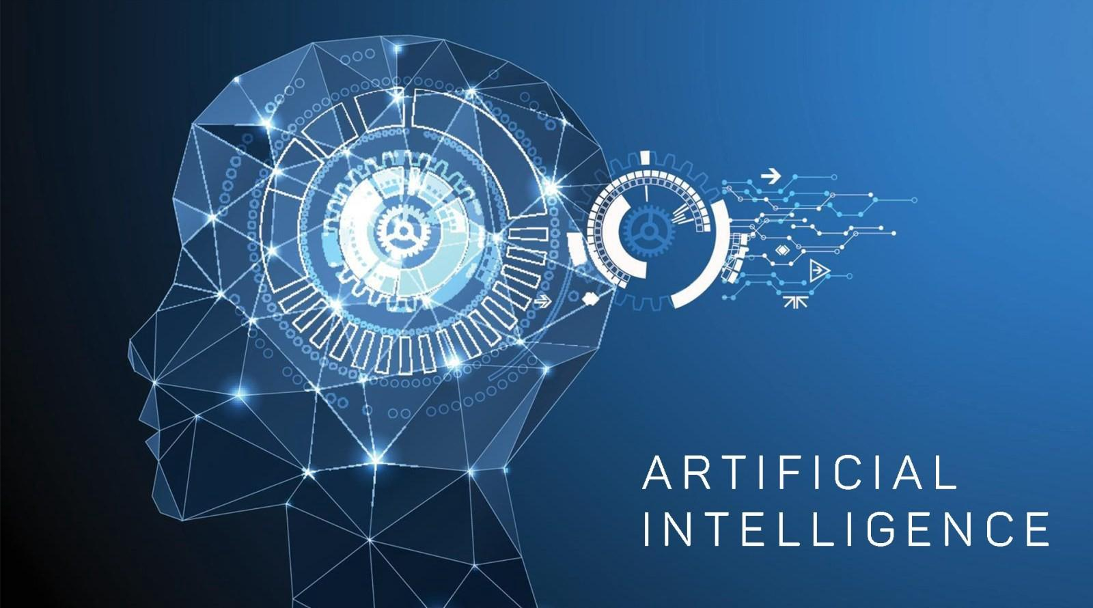

The **history of Artificial Intelligence** (**AI**) began in [antiquity](https://en.wikipedia.org/wiki/Ancient_history), with myths, stories and rumours of artificial beings endowed with intelligence or consciousness by master craftsmen. The seeds of modern AI were planted by classical philosophers who attempted to describe the process of human thinking as the mechanical manipulation of symbols. This work culminated in the invention of the [programmable digital computer](https://en.wikipedia.org/wiki/Computer) in the 1940s, a machine based on the abstract essence of mathematical reasoning. This device and the ideas behind it inspired a handful of scientists to begin seriously discussing the possibility of building an electronic brain.

The field of [AI](https://en.wikipedia.org/wiki/Artificial_intelligence) research was founded at a [workshop](https://en.wikipedia.org/wiki/Dartmouth_workshop) held on the campus of [Dartmouth College](https://en.wikipedia.org/wiki/Dartmouth_College) during the summer of 1956.[[1]](https://en.wikipedia.org/wiki/History_of_artificial_intelligence#cite_note-1) Those who attended would become the leaders of AI research for decades. Many of them predicted that a machine as intelligent as a human being would exist in no more than a generation, and they were given millions of dollars to make this vision come true.

Eventually, it became obvious that they had grossly underestimated the difficulty of the project. In 1973, in response to the criticism from [James Lighthill](https://en.wikipedia.org/wiki/James_Lighthill) and ongoing pressure from congress, the [U.S.](https://en.wikipedia.org/wiki/DARPA) and [British Governments](https://en.wikipedia.org/wiki/British_Government) stopped funding undirected research into artificial intelligence, and the difficult years that followed would later be known as an "[AI winter](https://en.wikipedia.org/wiki/AI_winter)". Seven years later, a visionary initiative by the [Japanese Government](https://en.wikipedia.org/wiki/Japanese_Government) inspired governments and industry to provide AI with billions of dollars, but by the late 80s the investors became disillusioned and withdrew funding again.

Investment and interest in AI boomed in the first decades of the 21st century when [machine learning](https://en.wikipedia.org/wiki/Machine_learning) was successfully applied to many problems in academia and industry due to new methods, the application of powerful computer hardware, and the collection of immense data sets.

Artificial Intelligence is the most popular technology of the 21st century. With the help of Artificial Intelligence, Machines can learn from their experiences, adapt to new inputs, and perform human tasks. For example, self-driving cars, chess-playing computers, adding movements to the old photos are the best examples of Artificial Intelligence. Moreover, the scope of AI is very high these days, and it will surely increase more in the future. In this blog, you will find all the information about what AI is and why artificial intelligence is important.

**Artificial Intelligence in Daily Life**

Artificial intelligence is changing the way of our living. If someone from the 20th century travels through time to 2021, he would wonder to see us using our mobile phones to travel around town, how Alexa and google assistance respond to our voice commands, and how people are more active on social media than in real life. Moreover, artificial intelligence has changed a lot in our life in the past 10-15 years. Furthermore, It is not wrong if artificial intelligence is an essential part of our daily life.

**Advantages/Applications of Ai**

1. Highly advanced organizations already implemented machines on behalf of humans to interact with their customers by using ‘avatars’. It is the digital assistants or replicas which will help to reduce the need for human resources.
2. Machine intelligence can be employed to carry out dangerous tasks which may cause injury to the human involved in that. Their parameters can be adjusted is the benefit here. Their speed and time can be customized based on the requirement calculation
3. One of the great advantages of Artificial Intelligence is utilized in the field of medicine. We can identify the numerous numbers of medical applications which rely on AI

**Introduction to Machine Learning**

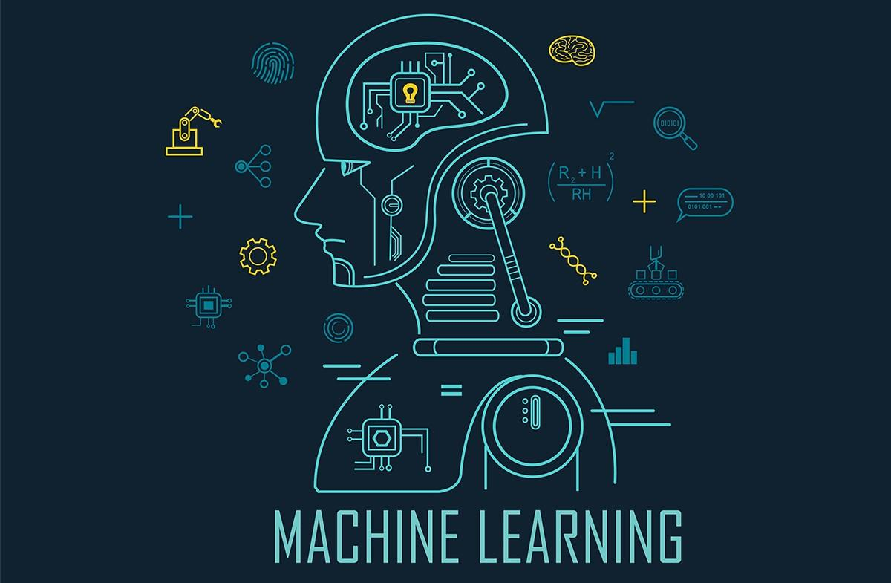

**Machine learning** (**ML**) is the study of computer [algorithms](https://en.wikipedia.org/wiki/Algorithm) that improve automatically through experience and by the use of data.[[1]](https://en.wikipedia.org/wiki/Machine_learning#cite_note-1) It is seen as a part of [artificial intelligence](https://en.wikipedia.org/wiki/Artificial_intelligence). Machine learning algorithms build a model based on sample data, known as "[training data](https://en.wikipedia.org/wiki/Training_data)", in order to make predictions or decisions without being explicitly programmed to do so.[[2]](https://en.wikipedia.org/wiki/Machine_learning#cite_note-2) Machine learning algorithms are used in a wide variety of applications, such as in medicine, [email filtering](https://en.wikipedia.org/wiki/Email_filtering), and [computer vision](https://en.wikipedia.org/wiki/Computer_vision), where it is difficult or unfeasible to develop conventional algorithms to perform the needed tasks.

A subset of machine learning is closely related to [computational statistics](https://en.wikipedia.org/wiki/Computational_statistics), which focuses on making predictions using computers; but not all machine learning is statistical learning. The study of [mathematical optimization](https://en.wikipedia.org/wiki/Mathematical_optimization) delivers methods, theory and application domains to the field of machine learning. [Data mining](https://en.wikipedia.org/wiki/Data_mining) is a related field of study, focusing on [exploratory data analysis](https://en.wikipedia.org/wiki/Exploratory_data_analysis) through [unsupervised learning](https://en.wikipedia.org/wiki/Unsupervised_learning). In its application across business problems, machine learning is also referred to as [predictive analytics](https://en.wikipedia.org/wiki/Predictive_analytics). Machine learning involves computers discovering how they can perform tasks without being explicitly programmed to do so. It involves computers learning from data provided so that they carry out certain tasks. For simple tasks assigned to computers, it is possible to program algorithms telling the machine how to execute all steps required to solve the problem at hand; on the computer's part, no learning is needed. For more advanced tasks, it can be challenging for a human to manually create the needed algorithms. In practice, it can turn out to be more effective to help the machine develop its own algorithm, rather than having human programmers specify every needed step. Modern day machine learning has two objectives, one is to classify data based on models which have been developed, the other purpose is to make predictions for future outcomes based on these models. A hypothetical algorithm specific to classifying data may use computer vision of moles coupled with supervised learning in order to train it to classify the cancerous moles. Whereas, a machine learning algorithm for stock trading may inform the trader of future potential predictions.

**Applications / Advantages of ML**

1. Image recognition is one of the most common applications of machine learning. It is used to identify objects, persons, places, digital images, etc. The popular use case of image recognition and face detection is, Automatic friend tagging suggestion:

Facebook provides us a feature of auto friend tagging suggestion. Whenever we upload a photo with our Facebook friends, then we automatically get a tagging suggestion with name, and the technology behind this is machine learning's **face detection** and **recognition algorithm**.

1. While using Google, we get an option of "Search by voice," it comes under speech recognition, and it's a popular application of machine learning.
2. Speech recognition is a process of converting voice instructions into text, and it is also known as "Speech to text", or "Computer speech recognition." At present, machine learning algorithms are widely used by various applications of speech recognition. Google assistant, Siri, Cortana, and Alexa are using speech recognition technology to follow the voice instructions
3. One of the most exciting applications of machine learning is self-driving cars. Machine learning plays a significant role in self-driving cars. Tesla, the most popular car manufacturing company, is working on self-driving car. It is using an unsupervised learning method to train the car models to detect people and objects while driving.

### **1.6: Application of Thesis**

**Theft Detection Door Locking**

he most important of feature of any home security system is to detect the people who enter or leave the house. Instead of monitoring that through passwords or pins unique faces can be made use of as they are one’s biometric trait. These are innate and cannot be modified or stolen easily. The level of security can be raised by using face detection. The proposed face recognition door lock security system has been developed to prevent robbery in highly secure areas like home environment with lesser power consumption and more reliable standalone security device for both Intruder detection and for door security. This system runs a timer program where the entry time and exit time of user is noted and allows user to access in certain amount of time, If user spend more time or reaches the time limit the door will be locked and sends a Alarm / warning Message to the user on the Screen. Whenever the person comes in front of the door, it recognizes the face and if it is registered then it unlocks the door, if the face is not registered it will raise admin form on screen for storing new user data set and send details to the admin through WhatsApp, So when the admin gives access to the user by sending one time password the system starts face storing of new user and entry is noted in the backend excel sheet. This is how the system works

## Chapter 2

**Overview of Software**

### **2.1 Introduction**

Software is a collection of instructions and data that tell a computer how to work. This is in contrast to physical hardware, from which the system is built and actually performs the work. In computer science and software engineering, computer software is all information processed by computer systems, including programs and data. Computer software includes computer programs, libraries and related non-executable data, such as online documentation or digital media. Computer hardware and software require each other and neither can be realistically used on its own.

At the lowest programming level, executable code consists of machine language instructions supported by an individual processor—typically a central processing unit (CPU) or a graphics processing unit (GPU). A machine language consists of groups of binary values signifying processor instructions that change the state of the computer from its preceding state. For example, an instruction may change the value stored in a particular storage location in the computer—an effect that is not directly observable to the user. An instruction may also invoke one of many input or output operations, for example displaying some text on a computer screen; causing state changes which should be visible to the user. The processor executes the instructions in the order they are provided, unless it is instructed to "jump" to a different instruction, or is interrupted by the operating system. As of 2015, most personal computers, smartphone devices and servers have processors with multiple execution units or multiple processors performing computation together, and computing has become a much more concurrent activity than in the past.

The majority of software is written in high-level programming languages. They are easier and more efficient for programmers because they are closer to natural languages than machine languages.[1] High-level languages are translated into machine language using a compiler or an interpreter or a combination of the two. Software may also be written in a low-level assembly language, which has strong correspondence to the computer's machine language instructions and is translated into machine language using an assembler.

# 

### **2.2 Full Stack Development**

|  |  |
| --- | --- |
|  | (Front-End) (Back-End)  Coding programming  Graphical User Data Storing  Interface (GUI) |
|  |  |

**2.3.1 Front-End**

Front-end development is the work on the visual, client-facing aspects of an application or website – the user interface and related. In the front end development mostly HTML , JavaScript, CSS and various API’s are used, but for this particular project python is used to create the front end user interface as it is better than any of the other languages as well easy to understand. The use python is done because in python front end design we can modify our UI components , sever side function calling is easy, binary data is easy to handle etc.

**2.3.2 Source Code**

In computing, source code is any collection of code, with or without comments, written using a human readable programming language, usually as plain text. The source code of a program is specially designed to facilitate the work of computer programmers, who specify the actions to be performed by a computer mostly by writing source code. The source code is often transformed by an assembler or compiler into binary machine code that can be executed by the computer. The machine code might then be stored for execution at a later time. Alternatively, source code may be interpreted and thus immediately executed.

Most application software is distributed in a form that includes only executable files. If the source code were included it would be useful to a user, programmer or a system administrator, any of whom might wish to study or modify the program.

**2.3.3 Back-End**

The back end refers to parts of a computer application or a program's code that allow it to operate and that cannot be accessed by a user. Most data and operating syntax are stored and accessed in the back end of a computer system. Typically, the code is composed of one or more programming languages. The back end is also called the data access layer of software or hardware and includes any functionality that needs to be accessed and navigated to by digital means. A back-end application or program supports front-end user services, and interfaces with any required resources. The back-end application may interact directly with the front end or it may be called from an intermediate program that mediates front-end and back-end activities. The Back end system consists of scripting languages, automated frameworks, database management and data transformation, network scalability and availability.

### **2.4 Introduction to Integrated Development and learning environment (IDLE)**

**What is IDLE**

IDLE is intended to be a simple Integrated development environment and suitable for beginners, especially in an educational environment. To that end, it is cross-platform, and avoids feature clutter. According to the included README, its main features are: Multi-window text editor with syntax highlighting, autocompletion, smart indent and other. It allows programmers to easily write Python code. Just like Python Shell, can be used to execute a single statement and create, modify, and execute Python scripts. It also has a debugger with stepping and breakpoints features. This makes debugging easier.

**History**

IDLE (short for Integrated Development and Learning Environment) is an integrated development environment for Python, which has been bundled with the default implementation of the language since 1.5.2b1. It is packaged as an optional part of the Python packaging with many Linux distributions. Author Guido van Rossum says IDLE stands for "Integrated Development and Learning Environment", and since Van Rossum named the language Python after the British comedy group Monty Python, the name IDLE was probably also chosen partly to honour Eric Idle, one of Monty Python's founding members.

**How to Use the Python IDLE Shell**

The shell is the default mode of operation for Python IDLE. When you click on the icon to open the program, the shell is the first thing that you see

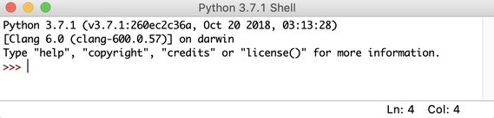

This is a blank Python interpreter window. You can use it to start interacting with Python immediately.

Next, take a look at the menu bar. You’ll see a few options for using the shell

You can restart the shell from this menu. If you select that option, then you’ll clear the state of the shell. It will act as though you’ve started a fresh instance of Python IDLE. The shell will forget about everything from its previous state.

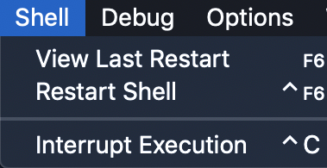

Python IDLE offers a full-fledged file editor, which gives you the ability to write and execute Python programs from within this program. The built-in file editor also includes several features, like code completion and automatic indentation, that will speed up your coding workflow.

### **2.5 Introduction to OpenCV module**

OpenCV is a huge open-source library for computer vision, machine learning, and image processing. OpenCV supports a wide variety of programming languages like Python, C++, Java, etc. It can process images and videos to identify objects, faces, or even the handwriting of a human. When it is integrated with various libraries, such as NumPy which is a highly optimized library for numerical operations, then the number of weapons increases in your Arsenal i.e. Whatever operations one can do in NumPy can be combined with OpenCV.

OpenCV was started at Intel in 1999 by Gary Bradsky, and the first release came out in 2000. Vadim Pisarevsky joined Gary Bradsky to manage Intel's Russian software OpenCV team. In 2005, OpenCV was used on Stanley, the vehicle that won the 2005 DARPA Grand Challenge. Later, its active development continued under the support of Willow Garage with Gary Bradsky and Vadim Pisarevsky leading the project. OpenCV now supports a multitude of algorithms related to Computer Vision and Machine Learning and is expanding day by day.

OpenCV supports a wide variety of programming languages such as C++, Python, Java, etc., and is available on different platforms including Windows, Linux, OS X, Android, and iOS. Interfaces for high-speed GPU operations based on CUDA and OpenCL are also under active development.

OpenCV-Python is the Python API for OpenCV, combining the best qualities of the OpenCV C++ API and the Python language.

OpenCV has a modular structure, which means that the package includes several shared or static libraries. The following modules are available:

* **Core functionality** (**core**) - a compact module defining basic data structures, including the dense multi-dimensional array Mat and basic functions used by all other modules.
* **Image Processing** (**imgproc**) - an image processing module that includes linear and non-linear image filtering, geometrical image transformations (resize, affine and perspective warping, generic table-based remapping), color space conversion, histograms, and so on.
* **Video Analysis** (**video**) - a video analysis module that includes motion estimation, background subtraction, and object tracking algorithms.
* **Camera Calibration and 3D Reconstruction** (**calib3d**) - basic multiple-view geometry algorithms, single and stereo camera calibration, object pose estimation, stereo correspondence algorithms, and elements of 3D reconstruction.
* **2D Features Framework** (**features2d**) - salient feature detectors, descriptors, and descriptor matchers.
* **Object Detection** (**objdetect**) - detection of objects and instances of the predefined classes (for example, faces, eyes, mugs, people, cars, and so on).
* **High-level GUI** (**highgui**) - an easy-to-use interface to simple UI capabilities.
* **Video I/O** (**videoio**) - an easy-to-use interface to video capturing and video codecs.
* ... some other helper modules, such as FLANN and Google test wrappers, Python bindings, and others.

**OpenCV-Python**

OpenCV-Python is a library of Python bindings designed to solve computer vision problems.

**How to install OpenCV for Python in Windows:**

To install OpenCV, one must have Python and PIP, preinstalled on their system. To check if your system already contains Python, go through the following instructions:

Open the Command line (search for cmd in the Run dialog (Win **+ R**)).

Now run the following command:

python –version

If Python is already installed, it will generate a message with the Python version available. If python isn’t available install it .

OpenCV can be directly downloaded and installed with the use of pip (package manager). To install OpenCV, just go to the command-line and type the following command: pip install opencv-python

To check if OpenCV is correctly installed, just run the following commands to perform a version check: python

>>>import cv2

>>>print(cv2.__version__)

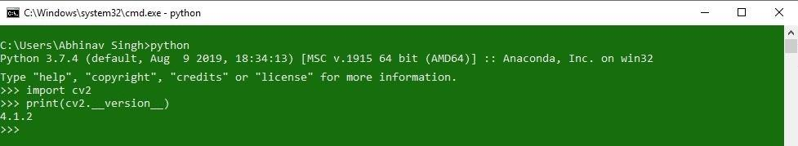

### **2.6 Workflow block diagram of the project**

**(General)**

(Front-End) (Back-End)

Coding programming

Graphical User Data Storing

Interface (GUI)

**(This Project)**

(Front-End) (Back-End)

GUI is made Code is written using Data is stored

In python python and opencv in an excel file

Using tkinter libraries are used containing the

Information

Of the admin/

User.

O

Chapter 3: Face & Eye Detection

### **Chapter 3**

# Chapter 3

**Face and Eye Detection**

### **3.1: Introduction**

Face detection is a type of application classified under “computer vision” technology. It is the process in which algorithms are developed and trained to properly locate faces or objects (in object detection, a related system), in images. These can be in real time from a video camera or from photographs. An example where this technology is used are in airport security systems. In order to recognize a face, the camera software must first detect it and identify the features before making an identification. Likewise, when Facebook makes tagging suggestions to identify people in photos it must first locate the face. On social media apps like Snapchat, face detection is required to augment reality which allows users to virtually wear dog face masks using fancy filters. Another use of face detection is in smartphone face ID security.

In this project, we implemented a system for locating faces in digital images. These are in JPEG format only. Before we continue, we must differentiate between face recognition and face detection. They are not the same, but one depends on the other. In this case face recognition needs face detection for making an identification to “recognize” a face. we will only cover face detection.

Face detection uses classifiers , which are algorithms that detects what is either a face(1) or not a face(0) in an image. Classifiers have been trained to detect faces using thousands to millions of images in order to get more accuracy. OpenCV uses two types of classifiers, LBP (Local Binary Pattern) and Haar Cascades.

**Haar Cascades**

Haar Cascade classifier is based on the Haar Wavelet technique to analyse pixels in the image into squares by function. This uses “integral image” concepts to compute the “features” detected. Haar Cascades use the **Ada-boost** learning algorithm which selects a small number of important features from a large set to give an efficient result of classifiers then use cascading techniques to detect face in a image. Here are some Haar-Features

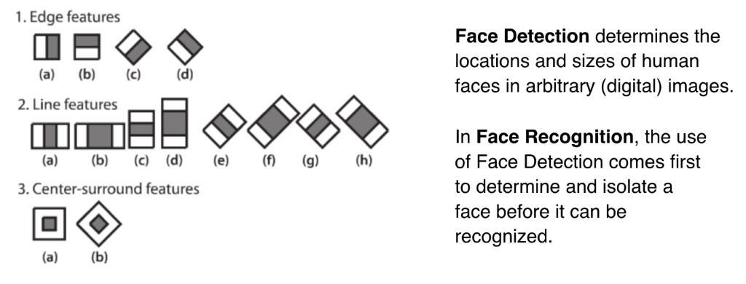

**Fig 3.1: Haar feature extraction kernels**.

**Feature Extraction**

As it was mentioned earlier, Haar Cascades use machine learning techniques in which a function is trained from a lot of positive and negative images. This process in the algorithm is feature extraction. Haar features are similar to these convolution kernels which are used to detect the presence of that feature in the given image. The first two are “edge features”, used to detect edges. The third is a “line feature”, while the fourth is a “four rectangle feature”, most likely used to detected a slanted line.

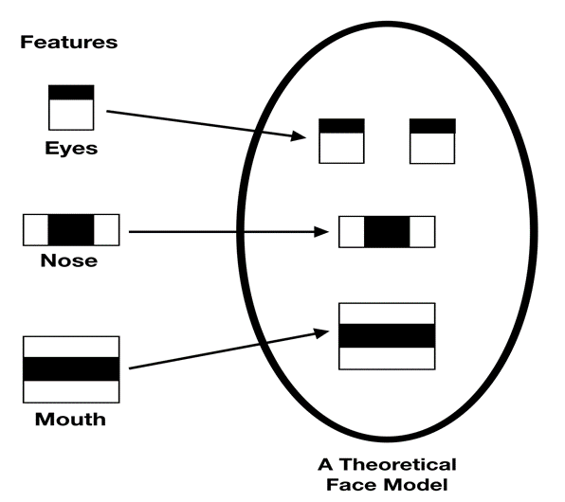

**Fig 3.2. Face Detection Kernels**

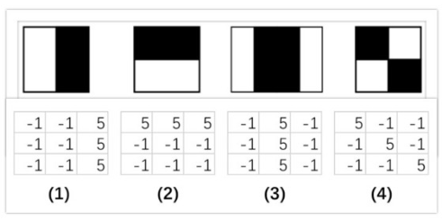

**Fig 3.3. Kernels.**

**Haar features applied to image**

Each feature results in a single value which is calculated by subtracting the sum of pixels under white rectangle from the sum of pixels under black rectangle. Every haar feature have some sort of resemblance to identify a part of face.

Value = ∑ (pixels in white area) – ∑ (pixels in black area)

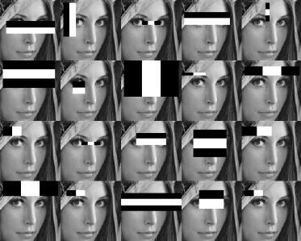

**Fig.3.4. Detection of face in different paths**

If we consider all possible parameters of the haar features like position, scale and type we end up calculating about 160,000+ features. So we need to evaluate huge set of features for every 24*24 PX.

So to avoid this we have a idea to avoid redundant features and pick only those features which are very useful for us. This can be done using AdaBoost

**Adaboost**

AdaBoost is a machine learning algorithm that able to find the best features among 160,000+ features. These features are also called as weak classifiers. After these features are found a weighted combination of all these features in used in evaluating and deciding any given window has a face or not. Each of the selected features (weak classifiers) are considered okay to be included if they can at least perform better than random guessing (detects more than half the cases). Each of the weak classifier is relevant detecting a part of face. Output of weak classifier is binary if it have identified a part of face or not.

Adaboost constructs a strong classifier as a linear combination of these weak classifiers. Strong classifier = linear sum of weak classifiers

F( x ) = ∑ ( αi * fi( x ) )

here αi are corresponding weights to each weak classifier fi(x)

Even if there are more face’s detected the excessive large amount of evaluated value remains negative. So the algorithm will more concentrate on discarding non faces and spending more time on probable face region. Hence a single strong classifier formed out of linear combination of all best features is not a good to evaluate on each window because of computation cost.

**Cascading**

We start with simple classifiers which reject many of the negative sub-windows while detecting almost all positive sub-windows. Positive response from the first classifier triggers the evaluation of a second (more complex) classifier, and so on . A negative outcome at any point leads to the immediate rejection of the sub-window.

Given a input image sub-window we need to move our 24*24 window all over the image and compute 2,500 features for every window and take a linear combination of all outputs and see if it exceeds a certain threshold or not.

• The basic principle of the Viola-Jones face detection algorithm is to scan the detector many times through the same image — each time with a new size.

• Even if an image should contain one or more faces it is obvious that an excessive large amount of the evaluated sub-windows will still be negatives (non- faces).

• So the algorithm should concentrate on discarding non-faces quickly and

spend more on time on probable face regions.

• Hence a single strong classifier formed out of linear combination of all best features is not a good to evaluate on each window because of computation cost.

Instead of calculating 2,500 features for every window we use idea of cascades. We do a sampling of 2,500 features into x different cascades. Now we can detect if there is face or not in different cascades linearly. If cascade finds a face in a image then image is passed to next cascade. If no face is found is a cascade we can move to next window. This reduces the time complexity.

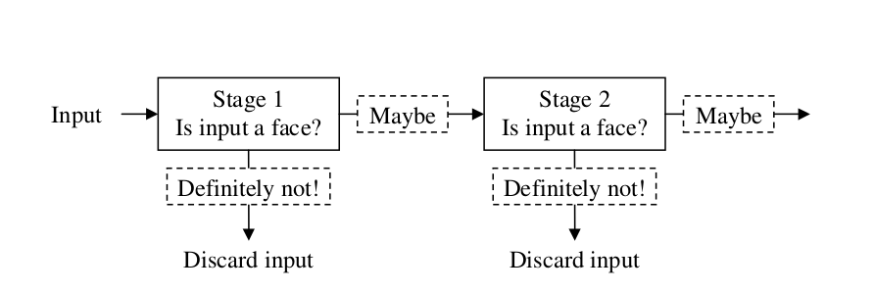

**Fig.3.5. Cascading**

The job of each stage is used to determine whether a given sub window is definitely not a face or may be a face. A given sub window is immediately discarded as not a face if it fails in any of the stage.

### **3.2 Open CV for Facial Recognition**

**Introduction**

OpenCV (Open Source Computer Vision Library) is an open source computer vision and machine learning software library. OpenCV was built to provide a common infrastructure for computer vision applications and to accelerate the use of machine perception in the commercial products. OpenCV was originally developed by Intel back in 1999 and is now maintained by Willow Garage and It See. OpenCV (Open Source Computer Vision) is a library of programming functions for real time computer vision, it uses a BSD license and hence it’s free for both academic and commercial use. It has C++, C, Python and Java (Android) interfaces and supports Windows, Linux, Android, iOS and Mac OS. It has more than 2500 optimized algorithms. Adopted all around the world, OpenCV has more than 9 million downloads growing by nearly 200K/month. Usage ranges from interactive art, to mines inspection, stitching maps on the web on through advanced robotics.

**History**

Officially launched in 1999 the OpenCV project was initially an Intel Research initiative to advance CPU -intensive applications, part of a series of projects including real-time ray tracing and 3D display walls. The main contributors to the project included a number of optimization experts in Intel Russia, as well as Intel's Performance Library Team. In the early days of OpenCV, the goals of the project were described as:

• Advance vision research by providing not only open but also optimized code for basic vision infrastructure. No more reinventing the wheel

• Disseminate vision knowledge by providing a common infrastructure that developers could build on, so that code would be more readily readable and transferable.

• Advance vision-based commercial applications by making portable performance- optimized code available for free – with a license that did not require code to be open or free itself.

The first alpha version of OpenCV was released to the public at the IEEE Conference on Computer Vision and Pattern Recognition in 2000, and five betas were released between 2001 and 2005. The first 1.0 version was released in 2006. A version 1.1 "pre-release" was

released in October 2008.

The second major release of the OpenCV was in October 2009. OpenCV 2 includes major changes to the C++ interface, aiming at easier, more type-safe patterns, new functions, and better implementations for existing ones in terms of performance (especially on multi-core systems). Official releases now occur every six months and development is now done by an independent Russian team supported by commercial corporations.

In August 2012, support for OpenCV was taken over by a non-profit foundation OpenCV.org, which maintains a developer and user site.

On May 2016, Intel signed an agreement to acquire Itseez,] a leading developer of OpenCV. OpenCV is a cross-platform library using which we can develop real-time computer vision applications. It mainly focuses on image processing, video capture and analysis including features like face detection and object detection.

Let’s start the chapter by defining the term "Computer Vision".

**Computer Vision**

Computer Vision can be defined as a discipline that explains how to reconstruct, interrupt, and understand a 3D scene from its 2D images, in terms of the properties of the structure present in the scene. It deals with modelling and replicating human vision using computer software and hardware.

Computer Vision overlaps significantly with the following fields −

* **Image Processing** − It focuses on image manipulation.
* **Pattern Recognition** − It explains various techniques to classify patterns.
* **Photogrammetry** − It is concerned with obtaining accurate measurements from images.

Computer Vision Vs Image Processing

**Image processing** deals with image-to-image transformation. The input and output of image processing are both images.

**Computer vision** is the construction of explicit, meaningful descriptions of physical objects from their image. The output of computer vision is a description or an interpretation of structures in 3D scene.

Features of OpenCV Library

Using OpenCV library, you can −

* Read and write images
* Capture and save videos
* Process images (filter, transform)
* Perform feature detection
* Detect specific objects such as faces, eyes, cars, in the videos or images.
* Analyse the video, i.e., estimate the motion in it, subtract the background, and track objects in it.

OpenCV was originally developed in C++. In addition to it, Python and Java bindings were provided. OpenCV runs on various Operating Systems such as windows, Linux, OSx, FreeBSD, Net BSD, Open BSD, etc.

This tutorial explains the concepts of OpenCV with examples using Java bindings. OpenCV Library Modules

Following are the main library modules of the OpenCV library. Core Functionality

This module covers the basic data structures such as Scalar, Point, Range, etc., that are used to build OpenCV applications. In addition to these, it also includes the multidimensional array **Mat**, which is used to store the images. In the Java library of OpenCV, this module is included as a package with the name **org.opencv.core**.

Image Processing

This module covers various image processing operations such as image filtering, geometrical image transformations, colour space conversion, histograms, etc. In the Java library of OpenCV, this module is included as a package with the  
name **org.opencv.imgproc**.

Video

This module covers the video analysis concepts such as motion estimation, background subtraction, and object tracking. In the Java library of OpenCV, this module is included as a package with the name **org.opencv.video**

**Setup OpenCV with PyCharm Environment**

PyCharm is a cross-platform IDE used in computer programming specifically for Python. The platform developed by JetBrains is mainly used in code analysis, graphical debugger etc… It supports web development with Django as well as Data Science with Anaconda. We used PyCharm IDLE in our project for software execution, the following are steps to import open Cv on PyCharm.

1. Go to the terminal option at the bottom of the IDE window.

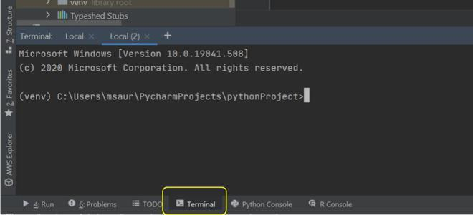

**2)** The pip (package manager) can also be used to download and install OpenCV. To install OpenCV, just type the following command:

**pip install opencv-python**

**3)** Now simply import OpenCV in your python program in which you want to use image processing functions.

To check if OpenCV is correctly installed, just run the following program in PyCharm to perform a version check:

**import cv2**

**print("GeeksForGeeks")**

**print("Your OpenCV version is: " + cv2.__version__)**

#### Output:

GeeksForGeeks

Your OpenCV version is: 4.4.0

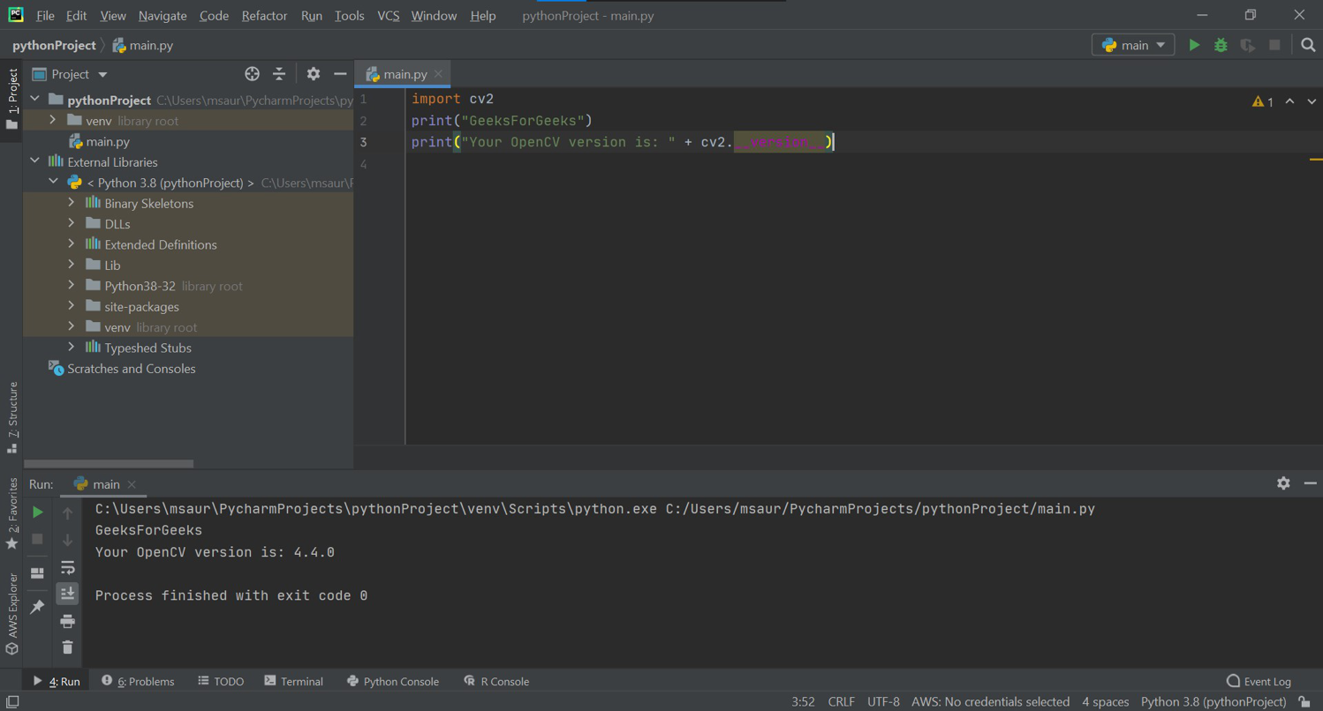

**Recommended Libraries to Install**

There are also other libraries to install that will come in handy when you do object detection and other projects, so I highly recommend you to also install these.

NumPy

The first library is NumPy — a library that makes array operations in Python easy to perform. Install NumPy by typing the following command:

pip3 install python-numpy

Matplotlib

The second library is Matplotlib. Matplotlib is a Python plotting library that produces publication quality figures in a variety of hard copy formats and interactive environments across platforms. Install Matplotlib by typing the following command:

pip3 install python-matplotlib

**Applications of Computer Vision**

Here we have listed down some of major domains where Computer Vision is heavily used. Robotics Application

* Localization − Determine robot location automatically
* Navigation
* Obstacles avoidance
* Assembly (peg-in-hole, welding, painting)
* Manipulation (e.g. PUMA robot manipulator)
* Human Robot Interaction (HRI) − Intelligent robotics to interact with and serve people

**Medicine Application**

* Classification and detection (e.g. lesion or cells classification and tumour detection)
* 2D/3D segmentation
* 3D human organ reconstruction (MRI or ultrasound)
* Vision-guided robotics surgery

Industrial Automation Application

* Industrial inspection (defect detection)
* Assembly
* Barcode and package label reading
* Object sorting
* Document understanding (e.g. OCR) Security Application
* Biometrics (iris, finger print, face recognition)
* Surveillance − Detecting certain suspicious activities or behaviours
* Autonomous vehicle Safety, e.g., driver vigilance monitoring

**Industrial Automation**

Automatic inspection of objects and classifying them into different categories play a major role in manufacturing industries. Industrial robots use computer vision algorithms to perform various tasks like separating two or more different objects into their respective categories, detecting whether the product is labelled or not. If not, then we can reject the product on the conveyor belt.

**Medical Image Processing**

The progress in computer vision has led to extensive use of the medical imaging data to provide us with better prediction, diagnosis, and treatment of diseases. Some examples of this are the detection of tumours, arteriosclerosis or other malign changes, measurement of organ dimensions, blood flow, enhancement of ultrasonic or X-ray images that are interpreted by humans.

**Self-driving Vehicles**

Artificial intelligence is on the boom right now and companies are investing in self-driving technology. Computer vision is used to detect lanes and find a path for autonomous vehicles. Information from various sensors is analysed and used to detect objects on the path like traffic lights, traffic signs and according to obstacles, we decide the appropriate action that needs to be taken.

**Military Applications**

The military is probably one of the largest areas for computer vision. More advanced systems for missile guidance are developed to make dynamic decisions based on the information provided by various sensors including image sensors. Modern military concepts are emerging like “Battlefield awareness” in which strategic decisions are made after analysing the information provided by sensors, detecting enemy soldiers or vehicles.

**Event Detection**

CCTV cameras are everywhere around us in offices, roads, hospitals, banks, train stations, parking lots, etc and 24/7 surveillance is difficult. The computer vision techniques allow us to monitor the events in real-time and detect anomalies or any specific action detection. Automatic Number Plate Recognition (ANPR) system can be used to control automatic gates, vehicle tracking, analysing crowd and counting number of people.

### **3.3 Flowchart For Face/ Eye Detection**

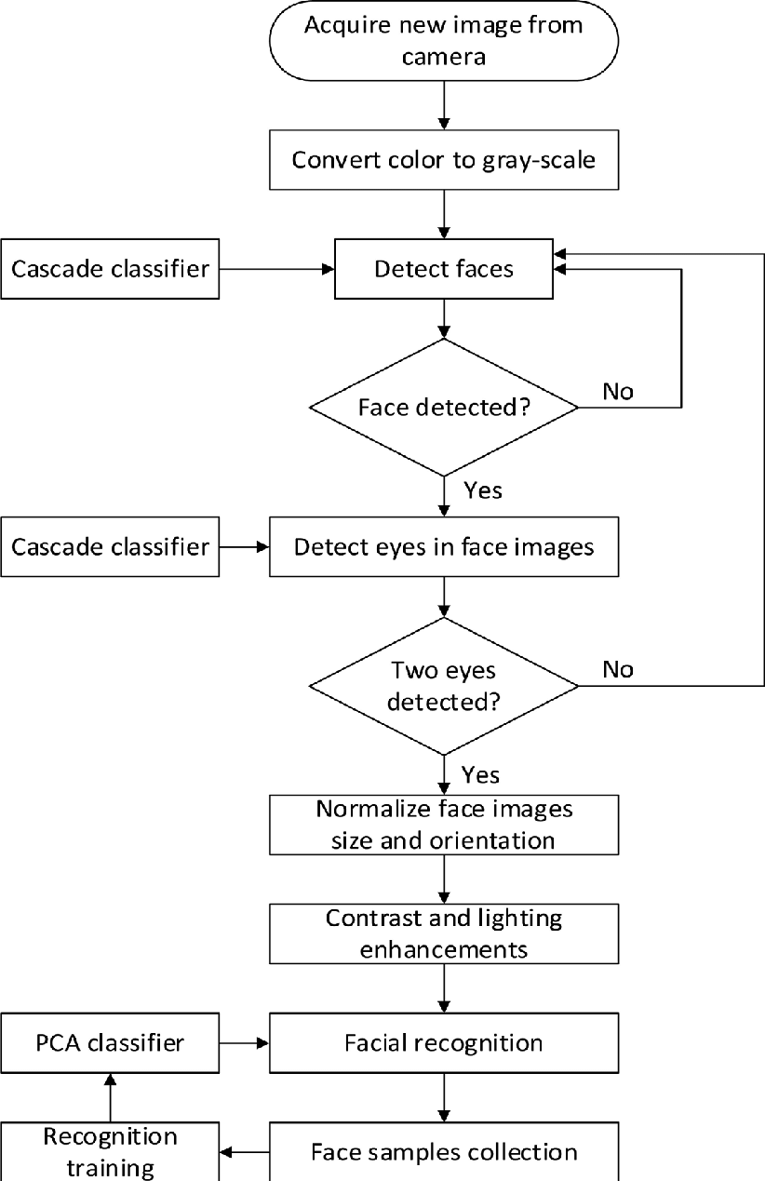

### **3.4 Algorithm behind Face Detection**

Face detection involves separating image windows into two classes; one containing faces (tarning the background (clutter). It is difficult because although commonalities exist between faces, they can vary considerably in terms of age, skin colour and facial expression. The problem is further complicated by differing lighting conditions, image qualities and geometries, as well as the possibility of partial occlusion and disguise. An ideal face detector would therefore be able to detect the presence of any face under any set of lighting conditions, upon any background. The face detection task can be broken down into two steps. The first step is a classification task that takes some arbitrary image as input and outputs a binary value of yes or no, indicating whether there are any faces present in the image. The second step is the face localization task that aims to take an image as input and output the location of any face or faces within that image as some bounding box with (x, y, width, height).

**The face detection system can be divided into the following steps:-**

**Pre-Processing:** To reduce the variability in the faces, the images are processed before they are fed into the network. All positive examples that is the face images are obtained by cropping images with frontal faces to include only the front view. All the cropped images are then corrected for lighting through standard algorithms.

**Classification:** Neural networks are implemented to classify the images as faces or nonfaces by training on these examples. We use both our implementation of the neural network and the Matlab neural network toolbox for this task. Different network configurations are experimented with to optimize the results.

**Localization:** The trained neural network is then used to search for faces in an image and if present localize them in a bounding box. Various Feature of Face on which the work has done on:- Position Scale Orientation Illumination

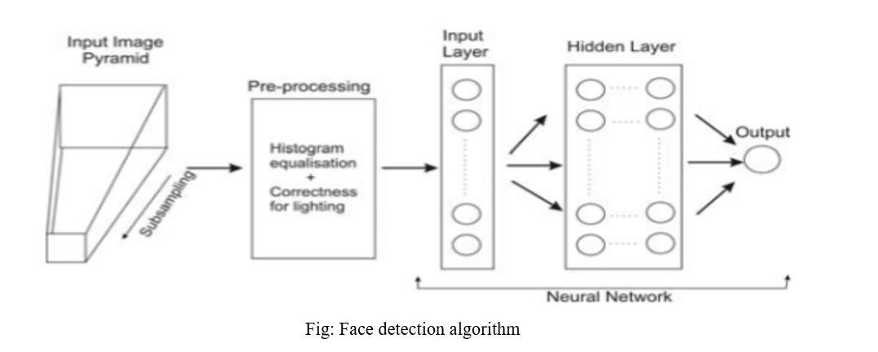

### **3.5 Face Detection**

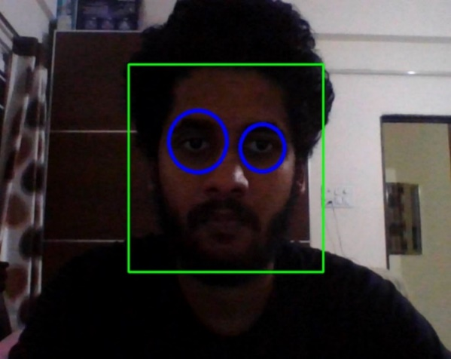 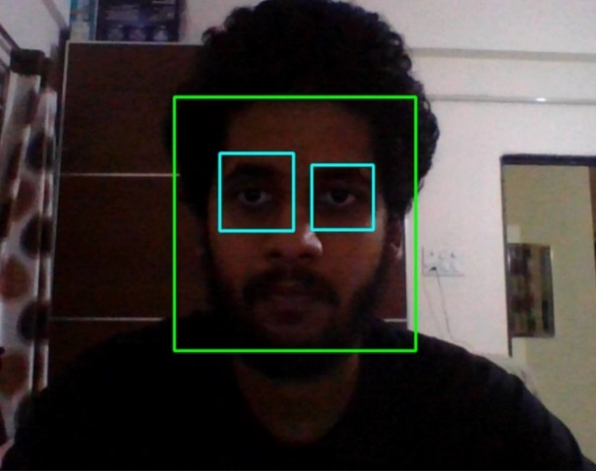

There will be a circle or square appearing on our eyes when the system is detecting the eyes and face. The circle/square are user-based selection.

# Chapter 4

**Face Storing**

### **4.1 Introduction:**

Face storing is basically nothing but gathering all the images clicked by the web camera during the capturing of the faces and placing them in a secured place where in they can later be used by the system itself for the recognition purpose. The faces are stored in a particular folder named as “data faces” which is later called by the program for the recognition and granting the access to the admin/user. In this project the faces are stored with a predefined name “user x.x” this x.x is the numbering provided by the system to the user, total a set of 30 images are stored in the folder.

Example: A user is registered as number 3 then that particular user will have a set of 30 images stored as “user3.1 - 3.30” in the folder “dataset”.

### **4.2 Front End (GUI)**

**What is Front-End:**

Front-end development is the work on the visual, client-facing aspects of an application or website – the user interface and related. In the front-end development mostly HTML, JavaScript, CSS and various APIs are used, but for this particular project python is used to create the front-end user interface as it is better than any of the other languages as well easy to understand. The use python is done because in python front end design we can modify our UI components, sever side function calling is easy, binary data is easy to handle etc.

**Python -Tkinter**

Tkinter is the standard GUI library for Python. Python when combined with Tkinter provides a fast and easy way to create GUI applications. Tkinter provides a powerful object-oriented interface to the Tk GUI toolkit.

Creating a GUI application using Tkinter is an easy task. All you need to do is perform the following steps −

* Import the Tkinter module.
* Create the GUI application main window.
* Add one or more widgets to the GUI application.
* Enter the main event loop to take action against each event triggered by the user.

**Example**:

#!/usr/bin/python

import Tkinter

top = Tkinter.Tk()

# Code to add widgets will go here...

top.mainloop()

This would create a following window –

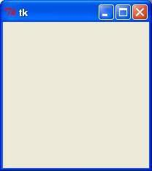

**Necessity**

Out of all the GUI methods, Tkinter is the most commonly used method. It is a standard Python interface to the Tk GUI toolkit shipped with Python. Python with Tkinter is the fastest and easiest way to create the GUI applications. Creating a GUI using Tkinter is an easy task.

There are a number of widgets which you can put in your Tkinter application. One of the major widgets are explained below:

1. **Button**: To add a button in your application, this widget is used.

The general syntax is:

**w=Button (master, option=value)**

master is the parameter used to represent the parent window.

There are number of options which are used to change the format of the Buttons. Number of options can be passed as parameters separated by commas. Some of them are listed below.

· **activebackground**: to set the background color when button is under the cursor.

· **activeforeground**: to set the foreground color when button is under the cursor.

· **bg**: to set he normal background color.

· **command**: to call a function.

· **font**: to set the font on the button label.

· **image**: to set the image on the button.

· **width**: to set the width of the button.

· **height**: to set the height of the button.

**Example:**

import Tkinter as tk

r = tk.Tk()

r.title('Counting Seconds')

button = tk.Button(r, text='Stop', width=25, command=r.destroy)

button.pack()

r.mainloop()

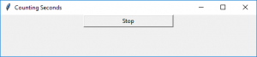

### **4.3 Back-End (Data storage)**

**What is Back-end**

The back end refers to parts of a computer application or a program's code that allow it to operate and that cannot be accessed by a user. Most data and operating syntax are stored and accessed in the back end of a computer system. Typically, the code is comprised of one or more programming languages. The back end is also called the data access layer of software or hardware and includes any functionality that needs to be accessed and navigated to by digital means. A back-end application or program supports front-end user services, and interfaces with any required resources. The back-end application may interact directly with the front end or it may be called from an intermediate program that mediates front-end and back-end activities. The Back-end system consists of scripting languages, automated frameworks, database management and data transformation, network scalability and availability.

**Pandas-Python**

Pandas is an open-source Python Library providing high-performance data manipulation and analysis tool using its powerful data structures. The name Pandas is derived from the word Panel Data – an Econometrics from Multidimensional data.

In 2008, developer Wes McKinney started developing pandas when in need of high performance, flexible tool for analysis of data.

Prior to Pandas, Python was majorly used for data munging and preparation. It had very little contribution towards data analysis. Pandas solved this problem. Using Pandas, we can accomplish five typical steps in the processing and analysis of data, regardless of the origin of data — load, prepare, manipulate, model, and analyze.

Python with Pandas is used in a wide range of fields including academic and commercial domains including finance, economics, Statistics, analytics, etc.

Key Features of Pandas

* Fast and efficient Data Frame object with default and customized indexing.
* Tools for loading data into in-memory data objects from different file formats.
* Data alignment and integrated handling of missing data.
* Reshaping and pivoting of date sets.
* Label-based slicing, indexing and sub setting of large data sets.
* Columns from a data structure can be deleted or inserted.
* Group by data for aggregation and transformations.
* High performance merging and joining of data.
* Time Series functionality.

Standard Python distribution doesn't come bundled with Pandas module. A lightweight alternative is to install NumPy using popular Python package installer, **pip.**

pip install pandas

If you install Anaconda Python package, Pandas will be installed by default.

In our project the pandas is used to store the information on the admin and users respectively.

**Reading and Writing Excel Files in Python with Pandas**

We'll be storing the information we'd like to write to an Excel file in a Data Frame. Using the built-in to excel() function, we can extract this information into an Excel file.

First, let's import the Pandas module:

import pandas as pd

Now, let's use a dictionary to populate a Data Frame:

{

df = pd.DataFrame({'States':['California', 'Florida', 'Montana', 'Colorodo', 'Washington', 'Virginia'],

'Capitals’: ['Sacramento', 'Tallahassee', 'Helena', 'Denver', 'Olympia', 'Richmond'],

'Population’: ['508529', '193551', '32315', '619968', '52555', '227032']})

}

The *keys* in our dictionary will serve as column names. Similarly, the *values* become the rows containing the information.

Now, we can use the to_excel() function to write the contents to a file. The only argument is the file path:

**df.to_excel('./states.xlsx')**

Here's the Excel file that was created.

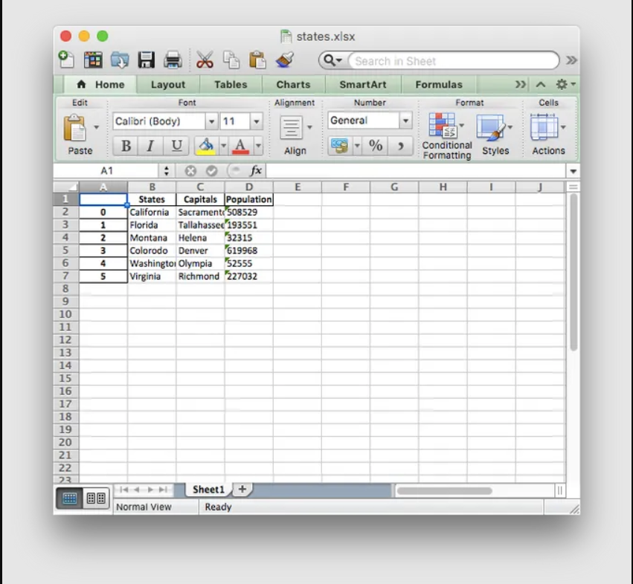

### **4.4 Face Storing**

When it comes to pattern recognition, a face identification system must store hundreds of thousands of feature vectors. The amount of vectors depends on the number of users. When identifying a person, the system not only recognizes the presence of a face in the frame but also highlights the face in the frame and finds a specific user.

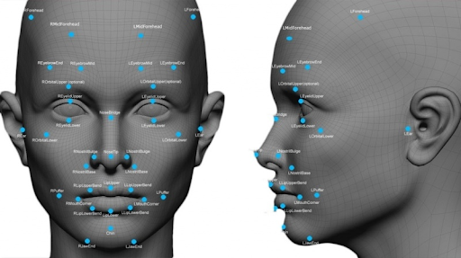

For example, when it comes to face recognition, the system measures such features as the distance between the eyes, the diameter of the eyes, the diameter of the nasal openings, the sharpness of the chin, and many other nuances. There are 128 such features in total.

The point of such painstaking measurements is that simply measuring face to face is not enough. Indeed, depending on the light, haircut, or the level of unshaven, the face can be identified in different ways. And such precise details can affect accuracy.

There are several methods of face storing . the method used for this particular project is

**All features serialized in one text column**

The features are contained in one column, and there is a text field containing an array of 128 features

In the first option, it is necessary to make a selection for all values in the features column, which takes longer to fill the table.

Initially, the table contains 200 vectors. We make a cycle of 1000 search queries and after each query, we add a new vector to the database - usually, this is what face search systems do.

Distribution of the number of requests by response time (ОХ - seconds, ОУ - number of requests).

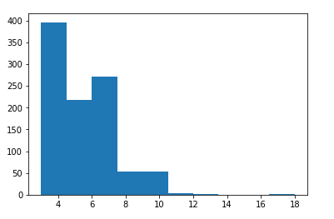

Average response time: 5.3s.

As you can see in the following graph, the linear load growth of the response time as the base increases. That is not very convenient.

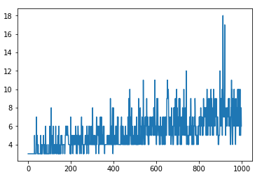

**How B&W or Grayscale images are stored in a Computer?**

Let’s take an example. Here we have taken a black and white image, also known as a Grayscale image.

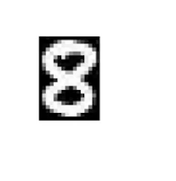

This is the image of a number 8. Now, if we zoom in further and if you look closely you can see that the images getting distorted and you would see some small square boxes on this image.

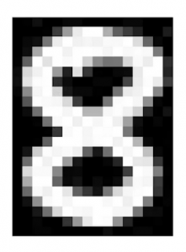

These small boxes are called **Pixels**. We often use the term- **the** **dimension** **of the image is X x Y**. What does that actually mean? This means that the dimension of the image is simply the number of pixels across the height(x) and width(y) of the image. In this case, if you count, it would be 24 pixels across the height and 16 pixels across the width. Hence the dimension of this image will be **24 x 16**. Although we see an image in this format the computer store image in the form of numbers-

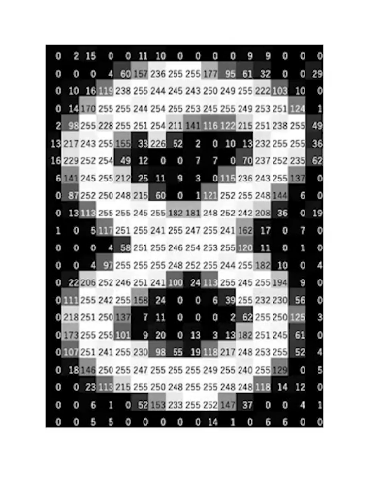

Each of these pixels is denoted as the numerical value and these numbers are called **Pixel Values**. These pixel values denote the intensity of the pixels. For a grayscale or b&w image, we have pixel values ranging from 0 to 255.

So every image in a computer is saved in this form where you have a matrix of numbers and this matrix is also known as **a Channel-**

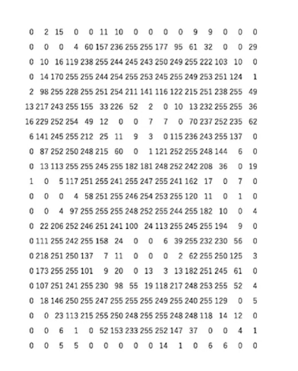

**How Colored images are stored on a computer**

Now that we have an idea about how are grayscale images stored in a computer, let’s look at an example for a colored image. So let’s take an example of a colored image, this is an image of a dog-

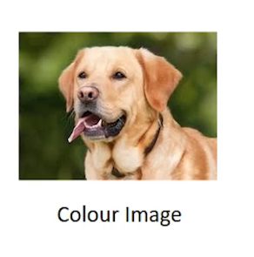

This image is composed of many colors and almost all colors can be generated from the three primary colors- **Red, Green, and Blue.** We can say that each colored image is composed of these three colors or 3 channels- Red, Green, and Blue-

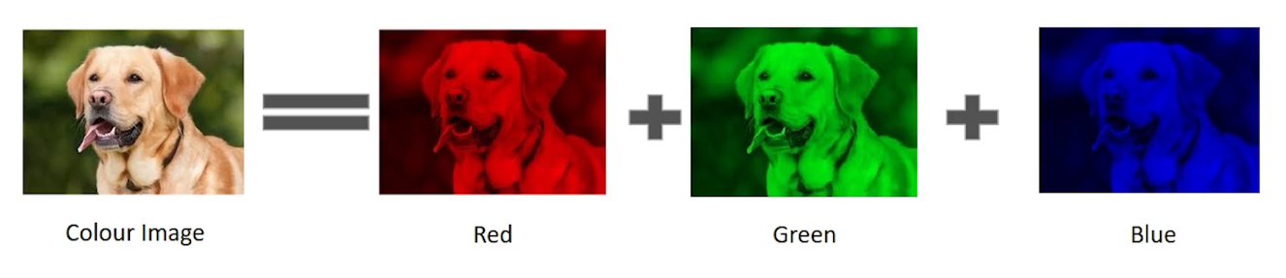

This means that in a colored image the number of matrices or the number of channels will be more. In this particular example, we have 3 matrices- 1 matrix for red known as Red channel-

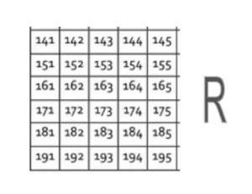

another metrics for green known as the Green channel-

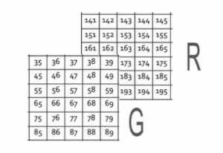

and finally a matrix for the blue color also known as the Blue channel.

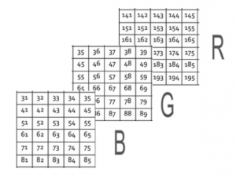

Each of these metrics would again have values ranging from 0 to 255 where each of these numbers represents the intensity of the pixels or you can say that the shades of red, green, and blue. Finally, all of these channels or all of these matrices are superimposed so the shape of the image, when loaded in a computer, will be-

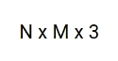

where N is the number of pixels across the height, M would be the number of pixels across the width, and 3 is representing the number of channels, in this case, we have 3 channels R, G, and B. In our example, the shape of the colored image would be- **6 x 5 x 3** since we have 6 pixels across the height, 5 across the width.

### **4.5 Security Additions/Utilities**

There are many loop holes which can be found for a facial recognition system. The main loophole will be the identification of high privileged user and the low privileged user. Then what are the information that is gathered by the system about the low privileged user and how is the access granted to the low privileged user to store his/her face. These main two reasons have been discussed and sorted out in this project using some of the freely available resources.

**Utilities**

* Taking into consideration the question of who is the high privileged user or rather referred as admin of the system and low privileged user.
* Taking a small example, the owner of a brand-new cell phone is always the high privileged user rather the admin/owner of the device. He/she has all the access as well as permissions to do everything with their device, Similarly the first person whoever access the webcam and stores their images is known as the admin of the system. The admin has to provide some inputs to the system which will be later used by the system for the upcoming users.
* The inputs to be provided to the system are:

1. Twillio registered mobile number
2. Twillio authentication id
3. Twillio authentication token
4. Twillio phone number (temporary number provided by twillio )

**What is Twillio**

**Twilio** is an American cloud communications platform as a service (CPaaS) company based in San Francisco, California. Twilio allows software developers to programmatically make and receive phone calls, send and receive text messages, and perform other communication functions using its web service APIs.

Twilio was founded in 2008 by Jeff Lawson, Evan Cooke, and John Wolthuis and was originally based in both Seattle, Washington, and San Francisco, California.

Twilio's first major press coverage, in November 2008, was the result of an application built by Jeff Lawson to rickroll people, which investor Dave McClure used on TechCrunch founder and editor Michael Arrington as a prank. A few days later on November 20, 2008, the company launched Twilio Voice, an API to make and receive phone calls completely hosted in the cloud. Twilio's text messaging API was released in February 2010, and SMS short codes were released in public beta in July 2011



**Technology**

Twilio uses Amazon Web Services to host telephony infrastructure and provide connectivity between HTTP and the public switched telephone network (PSTN) through its APIs.

· The use of Twillio in this project is done to send SMS to the admin user in order to give access to the low privileged user to store face .

· Twillio has its own library in python which we use in order to use it in the code of our project.

**To import Twillio in python**

**Pip install twillio -** this will install the twillio API in python.

**Import twillio -** this will import twillio API in our code

**OTP**

A **one-time password** (**OTP**), also known as a **one-time PIN** or **dynamic password**, is a password that is valid for only one login session or transaction, on a computer system or other digital device. OTPs avoid several shortcomings that are associated with traditional (static) password-based authentication; a number of implementations also incorporate two-factor authentication by ensuring that the one-time password requires access to *something a person has* (such as a small keyring fob device with the OTP calculator built into it, or a smartcard or specific cellphone) as well as *something a person knows* (such as a PIN).

OTP generation algorithms typically make use of pseudo randomness or randomness, making a prediction of successor OTPs by an attacker difficult, and also cryptographic hash functions, which can be used to derive a value but are hard to reverse and therefore difficult for an attacker to obtain the data that was used for the hash. This is necessary because otherwise, it would be easy to predict future OTPs by observing previous ones.

**OTP Generation**

Concrete OTP algorithms vary greatly in their details. Various approaches for the generation of OTPs include:

* Based on time-synchronization between the authentication server and the client providing the password (OTPs are valid only for a short period of time)
* Using a mathematical algorithm to generate a new password based on the previous password (OTPs are effectively a chain and must be used in a predefined order).
* Using a mathematical algorithm where the new password is based on a challenge (e.g., a random number chosen by the authentication server or transaction details) and/or a counter.

A common technology used for the delivery of OTPs is text messaging. Because text messaging is a ubiquitous communication channel, being directly available in nearly all mobile handsets and, through text-to-speech conversion, to any mobile or landline telephone, text messaging has a great potential to reach all consumers with a low total cost to implement. OTP over text messaging may be encrypted using an A5/x standard, which several hacking groups report can be successfully decrypted within minutes or seconds. Additionally, security flaws in the SS7 routing protocol can and have been used to redirect the associated text messages to attackers. Text messages are also vulnerable to SIM swap scams—in which an attacker fraudulently transfers a victim's phone number to their own SIM card, which can then be used to gain access to messages being sent to it.

After you sign up for an account on Twilio, head over to your Twilio Console and set up a Twilio phone number that can make voice calls as well as send SMS messages. This is the number from which the OTPs are going to be sent. You can add a phone number to your account in the Buy a Number page if you don’t already have one.

If you are using a trial Twilio account you will need to verify your own phone number with Twilio before it can receive calls or SMS messages from the Twilio number.

On your Twilio Console, copy your Account SID and Auth Token. We are going to need these values to authenticate with the Twilio service. At the root of the project’s directory, create a *.env* file and add paste your Twilio credentials, along with the Twilio phone number associated with your account.

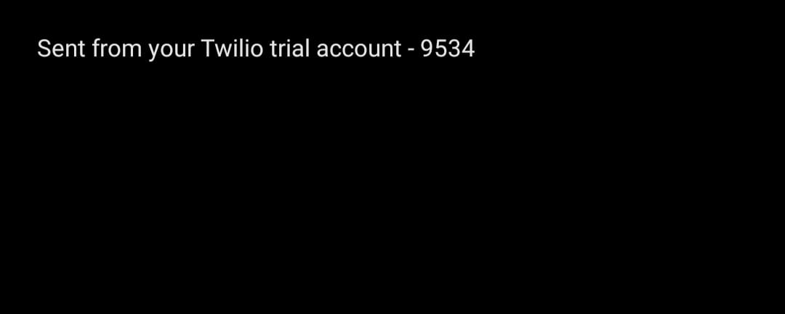

(Example of how otp is delivered to sender using twilio)

**WhatsApp Request**

Selenium is a powerful tool for controlling a web browser through the program. It is functional for all browsers, works on all major OS and its scripts are written in various languages i.e. Python, Java, C#, etc, we will be working with Python.

Mastering Selenium will help you automate your day to day tasks like controlling your tweets, WhatsApp texting, and even just googling without actually opening a browser in just 15-30 lines of python code. The limits of automation are endless with selenium.

**Selenium Bindings in Python**

Selenium Python bindings provide a convenient API to access Selenium Web Driver like Firefox, Chrome, etc.

Pip install Selenium

**Web Drivers**

Selenium requires a web driver to interface with the chosen browser. Web drivers is a package to interact with a web browser. It interacts with the web browser or a remote web server through a wire protocol which is common to all.

sudo apt-get install chromium-browser

*add some point here *

Keep your mobile phone with you. Choose WhatsApp web from the top bar in WhatsApp(3 dots)

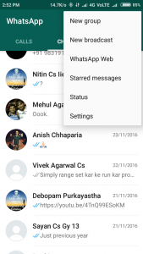

Then Run the script **( make sure that you have added the absolute path for chromedriver and have replaced target variable with your friends name ).** Scan the QR code that appears on the screen and enjoy the power of python!

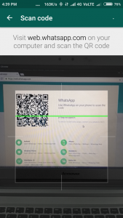 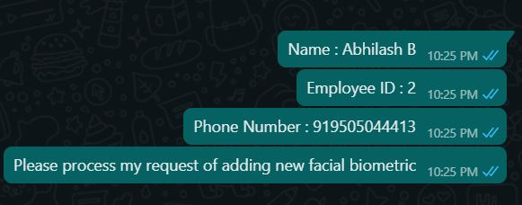

# 

# Chapter 5

**Face Training**

### **5.1 Introduction**

After applying a **face detection** on a given frame(image), the [**face recognition**](https://en.wikipedia.org/wiki/Facial_recognition_system)algorithm tries to find some match of that extracted face with the ones in the database(trained samples/images). The Training model creates a .yml or xml extension files which contains all the data features of users in the form of matrices and later this files is further used in Face Recognition.

The List of face Recognition algorithms include:

1. LBPH
2. Eigen Faces
3. Fisher Faces
4. SIFT
5. SURF
6. **LBPH Algorithm**

**Local binary patterns** (**LBP**) is a type of [visual descriptor](https://en.wikipedia.org/wiki/Visual_descriptor) used for classification in [computer vision](https://en.wikipedia.org/wiki/Computer_vision). LBP is the particular case of the Texture Spectrum model proposed in 1990.LBP was first described in 1994.It has since been found to be a powerful feature for texture classification; it has further been determined that when LBP is combined with the [Histogram of oriented gradients](https://en.wikipedia.org/wiki/Histogram_of_oriented_gradients) (HOG) descriptor, it improves the detection performance considerably on some datasets. A comparison of several improvements of the original LBP in the field of background subtraction was made in 2015 by Silva et al. A full survey of the different versions of LBP can be found in Bouwmans et al.

Each algorithm has its own instruction set and rules in order to recognize a face in a given picture. As mentioned in the title, our Face Recognition program is Based On LBPH Approach which is described in my previous post ([LBP](https://medium.com/swlh/local-binary-pattern-algorithm-the-math-behind-it-%EF%B8%8F-edf7b0e1c8b3))

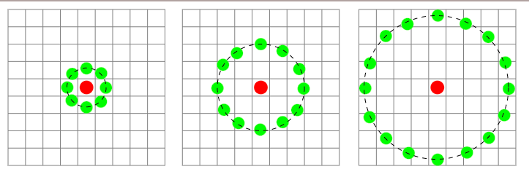

**Fig.5.1.1** Three neighbourhood examples used to define a texture and calculate a local binary pattern (LBP)

1. **Eigen Faces**

**Eigenfaces** refers to an appearance-based approach to face recognition that seeks to capture the variation in a collection of face images and use this information to encode and compare images of individual faces in a holistic (as opposed to a parts-based or feature-based) manner. Specifically, the eigenfaces are the principal components of a distribution of faces, or equivalently, the eigenvectors of the [covariance](http://www.scholarpedia.org/article/Covariance) matrix of the set of face images, where an image with N pixels is considered a point (or vector) in N dimensional space. The idea of using principal components to represent human faces was developed by Sirovich and Kirby (Sirovich and Kirby 1987) and used by Turk and Pentland (Turk and Pentland 1991) for face detection and recognition. The Eigenface approach is considered by many to be the first working facial recognition technology, and it served as the basis for one of the top commercial face recognition technology products. Since its initial development and publication, there have been many extensions to the original method and many new developments in automatic face recognition systems. Eigenfaces is still often considered as a baseline comparison method to demonstrate the minimum expected performance of such a system.

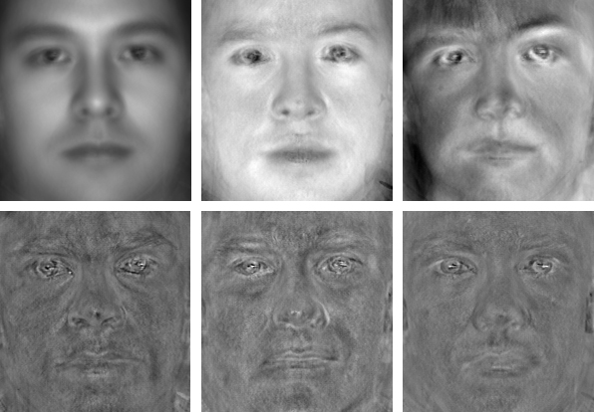

**Fig 5.1.2.** The leftmost in the first row is the average face, the others are top two eigenfaces;

the second row shows eigenfaces with least three eigenvalues.

1. **Fisher Faces**

A key problem in computer [vision](http://www.scholarpedia.org/article/Vision), pattern recognition and machine learning is to define an appropriate data representation for the task at hand.

One way to represent the input data is by finding a subspace which represents most of the data variance. This can be obtained with the use of Principal Components Analysis (PCA). When applied to face images, PCA yields a set of [eigenfaces](http://www.scholarpedia.org/article/Eigenfaces). These eigenfaces are the eigenvectors associated with the largest eigenvalues of the [covariance](http://www.scholarpedia.org/article/Covariance) matrix of the training data. The eigenvectors thus found correspond to the least-squares (LS) solution. This is indeed a powerful way to represent the data because it ensures the data variance is maintained while eliminating unnecessary existing correlations among the original features (dimensions) in the sample vectors.

When the goal is classification rather than representation, the LS solution may not yield the most desirable results. In such cases, one wishes to find a subspace that maps the sample vectors of the same class in a single spot of the feature representation and those of different classes as far apart from each other as possible. The techniques derived to achieve this goal are known as discriminant analysis (DA).

The most known DA is [Linear Discriminant Analysis](http://www.scholarpedia.org/article/Linear_Discriminant_Analysis) (LDA), which can be derived from an idea suggested by R.A. Fisher in 1936. When LDA is used to find the subspace representation of a set of face images, the resulting basis vectors defining that space are known as Fisher faces.

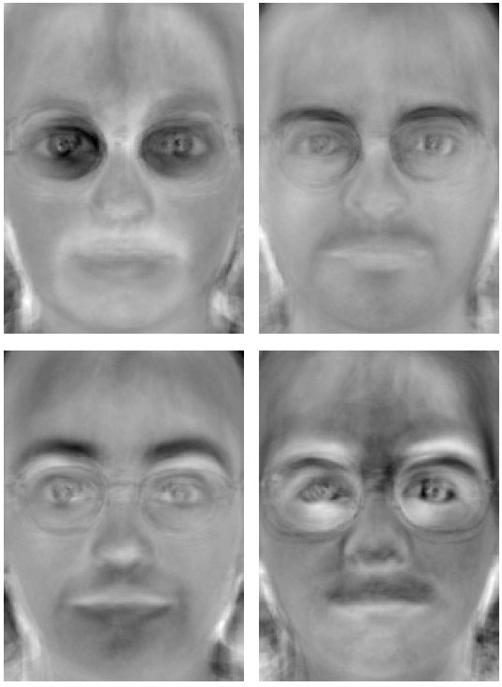

**Fig.5.1.3.** Shown here are the first four Fisher faces from a set of 100 classes (subjects)**.**

1. **SIFT**

The **scale-invariant feature transform** (**SIFT**) is a [feature detection](https://en.wikipedia.org/wiki/Feature_detection_(computer_vision)) algorithm in [computer vision](https://en.wikipedia.org/wiki/Computer_vision) to detect and describe local features in images. It was published by [David Lowe](https://en.wikipedia.org/wiki/David_G._Lowe) in 1999. Applications include [object recognition](https://en.wikipedia.org/wiki/Outline_of_object_recognition), [robotic mapping](https://en.wikipedia.org/wiki/Robotic_mapping) and navigation, [image stitching](https://en.wikipedia.org/wiki/Image_stitching), [3D modelling](https://en.wikipedia.org/wiki/3D_modeling), [gesture recognition](https://en.wikipedia.org/wiki/Gesture_recognition), [video tracking](https://en.wikipedia.org/wiki/Video_tracking), individual identification of wildlife and [match moving](https://en.wikipedia.org/wiki/Match_moving).

SIFT key points of objects are first extracted from a set of reference images and stored in a database. An object is recognized in a new image by individually comparing each feature from the new image to this database and finding candidate matching features based on [Euclidean distance](https://en.wikipedia.org/wiki/Euclidean_distance) of their feature vectors. From the full set of matches, subsets of key points that agree on the object and its location, scale, and orientation in the new image are identified to filter out good matches. The determination of consistent clusters is performed rapidly by using an efficient [hash table](https://en.wikipedia.org/wiki/Hash_table) implementation of the generalised [Hough transform](https://en.wikipedia.org/wiki/Hough_transform). Each cluster of 3 or more features that agree on an object and its pose is then subject to further detailed model verification and subsequently outliers are discarded. Finally the probability that a particular set of features indicates the presence of an object is computed, given the accuracy of fit and number of probable false matches. Object matches that pass all these tests can be identified as correct with high confidence.

1. **SURF**

In [computer vision](https://en.wikipedia.org/wiki/Computer_vision), **speeded up robust features** (**SURF**) is a patented local [feature detector](https://en.wikipedia.org/wiki/Feature_detection_(computer_vision)) and descriptor. It can be used for tasks such as [object recognition](https://en.wikipedia.org/wiki/Object_recognition), [image registration](https://en.wikipedia.org/wiki/Image_registration), [classification](https://en.wikipedia.org/wiki/Statistical_classification), or [3D reconstruction](https://en.wikipedia.org/wiki/3D_reconstruction). It is partly inspired by the [scale-invariant feature transform](https://en.wikipedia.org/wiki/Scale-invariant_feature_transform) (SIFT) descriptor. The standard version of SURF is several times faster than SIFT and claimed by its authors to be more robust against different image transformations than SIFT.

To detect interest points, SURF uses an integer approximation of the [determinant of Hessian](https://en.wikipedia.org/wiki/Blob_detection#The_determinant_of_the_Hessian) [blob detector](https://en.wikipedia.org/wiki/Blob_detection), which can be computed with 3 integer operations using a precomputed [integral image](https://en.wikipedia.org/wiki/Integral_image). Its feature descriptor is based on the sum of the [Haar wavelet](https://en.wikipedia.org/wiki/Haar-like_feature) response around the point of interest. These can also be computed with the aid of the integral image.

SURF descriptors have been used to locate and recognize objects, people or faces, to reconstruct 3D scenes, to track objects and to extract points of interest.

SURF was first published by [Herbert Bay](https://en.wikipedia.org/wiki/Herbert_Bay), Tinne Tuytelaars, and Luc Van Gool, and presented at the 2006 [European Conference on Computer Vision](https://en.wikipedia.org/wiki/European_Conference_on_Computer_Vision). An application of the algorithm is patented in the United States.[[1]](https://en.wikipedia.org/wiki/Speeded_up_robust_features#cite_note-1) An "upright" version of SURF (called U-SURF) is not invariant to image rotation and therefore faster to compute and better suited for application where the camera remains more or less horizontal.

The image is transformed into coordinates, using the [multi-resolution pyramid technique](https://en.wikipedia.org/wiki/Pyramid_(image_processing)), to copy the original image with Pyramidal Gaussian or Laplacian [Pyramid](https://en.wikipedia.org/wiki/Pyramid_(image_processing)) shape to obtain an image with the same size but with reduced bandwidth. This achieves a special blurring effect on the original image, called Scale-Space and ensures that the points of interest are scale invariant.

### **5.2 Face Training Algorithm – The LPHB Algorithm**

The main idea behind **LBP** is to describe the neighbourhood of image elements using **binary codes**. This method is usually used to study their local properties and identify the characteristics of individual parts of the image.

This algorithm is a combination of statistical and structural methods. It was first proposed by T. Ojala, [**M. Pietikanen**](https://en.wikipedia.org/wiki/Matti_Pietik%C3%A4inen_(academic)), T. Mehpaa from Oulu University in Finland in 1994. It is considered a theoretically time-effective and straightforward method, showing excellent results in many studies.

**How does it work?**

As the name suggests, Local Binary Pattern (LBP for short) is a feature of the local representation of an image. It is composed of relative values ​​by comparing each pixel with its neighbouring pixels.

The main characteristics of LBP are:

1-Low calculation cost

2-Resistance to fluctuations in image gray scale values

A lot of improvements have been made since the first proposal in 1994. Especially in non-deep learning systems, it is widely used for facial image recognition, texture segmentation, and other image analysis applications.

The LBP detects microstructures such as edges, lines, spots, flat areas, which can be estimated by the histogram.

**LBP Method Steps**

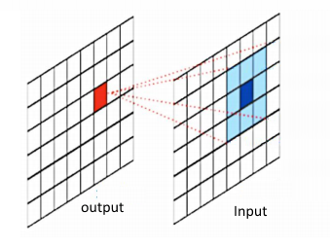

1- Convert the image into grayscale space.

2- For each pixel(gp) in the image, select the P neighbourhoods that surround the central pixel. the coordinates of gp are given by

(gc_x-Rsin(2πp/P),gc_y + Rcos(2πp/P))

3- Take the centre pixel (gc) and set it as a threshold for its P neighbours.

4- Set to 1 if the value of the adjacent pixel is greater than or equal to the value of the centre pixel, 0 otherwise.

5- Now compute the LBP value: Sequentially counter clockwise, write a binary number consisting of digits adjacent to the centre pixel. This binary number (or its decimal equivalent) is called LBP-central pixel code and, further, is used as a characteristic selected local texture.

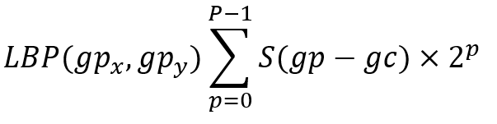

Uniform LBP formula

***gc-*** *the intensity value of the central pixel*

***gp-*** *the intensity of the neighbouring pixel with index p*

the function S can be expressed as:

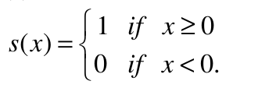

threshold (step) function

***P-*** *number of sampling points on a circle of radius R(circular neighborhood).*

***P-*** *controls the quantization of the method.*

***R-*** *determines the spatial resolution of the method or operator.*

The gray values of neighbours which do not fall exactly in the centre of a pixel(block) are estimated by interpolation.

**Detailed Example**

Now let’s take, for instance, the following chunk of a grayscale image:

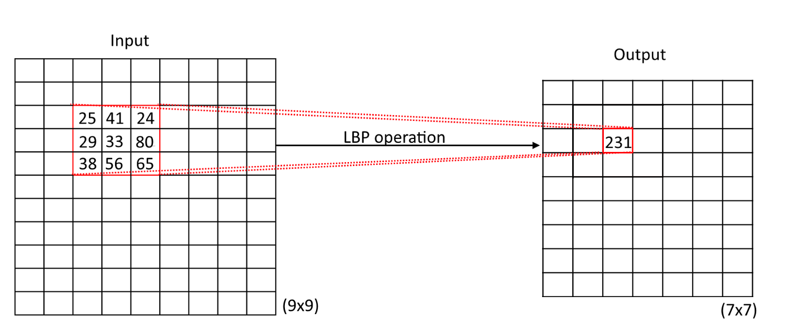

you can express the size of this window(3x3) in terms of The radius of the circle which equals to (2*R + 1), if the radius is 1, then we get a 3x3 matrix.

The coordinates of the central pixel denoted by gc(gc_x,gc_y) is (1,1) according to the coordinated axis of the matrix(3x3). The value of this pixel is 33(centre) gc =33. Let’s take for our example 8 neighbour samples (P=8). The coordinates of each sample point can be expressed as

(gc_x-Rsin(2πp/P),gc_y + Rcos(2πp/P))

P = 8

p = 0, 1 ,2 …,P-1

gc_x = gc_y = 1

So for the previous matrix, we have the following coordinates for each sample:

(gp_x,gp_y)

(g0_x,g0_y) => (1.0, 2.0)

(g1_x,g1_y) =>(0.2929, 1.7071)

.

.

.

(g7_x,g7_y) =>(1.7071, 1.7071)

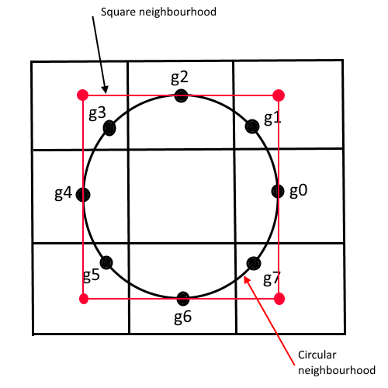

Lets denote by Theta_i = 2πp/P => Theta= 0, pi/4, pi/2, 3pi/4, pi, pi+pi/4, 3pi/2, 7pi/4

Now we need to compare, as the formula suggests, the intensity of each neighbor pixel with the intensity of the central one, gc.

g0 = 80

g1 = ?(on the circle at angle pi/4)

g2 = 41

g3 = ?

g4 = 29

g5 = ?

g6 = 56

g7 = ?

g0 = 80 > gc = 33 ==> put 1

g2 = 41 > gc = 33 ==> put 1

g4 = 29 < gc = 33 ==> put 0

g6 = 56 > gc = 33 ==> put 1

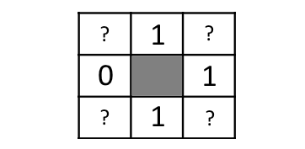

Now the problem is to find the intensity values of g1, g3, g5, g7

In order to find these values, [the paper](http://www.outex.oulu.fi/publications/pami_02_opm.pdf) suggests applying an interpolation.

Since we have a 2d space(2-dimensional image), we need a 2d interpolation method.

Now one of the methods that I do remember from my education in numerical analysis is the bilinear interpolation.

**Binary Interpolation**

The term [**Interpolatio**n](https://en.wikipedia.org/wiki/Interpolation#:~:text=In%20the%20mathematical%20field%20of,set%20of%20known%20data%20points.) is a way to calculate the intermediate value of a function from several of its already known values.

[**Bilinear interpolation**](https://en.wikipedia.org/wiki/Bilinear_interpolation#:~:text=In%20mathematics%2C%20bilinear%20interpolation%20is,again%20in%20the%20other%20direction.) is a linear interpolation of the function of two variables, that is, four-point interpolation. If the values ​​of the function at these points are known

f(x1,y1),f(x2,y1),f(x1,y2),f(x2,y2)

*Vectorization*It is reasonable to assume that the value at some point (x, y) located in the square bounded by these points can be found by interpolating twice, first by the x coordinate for two pairs of points, and then by the y coordinate, using the previous result.

In order to compute the intensity of g1, g3, g5, g7, we need to find the coordinates of the outer box containing the unknown pixel value.

So for example, g1, which lies in between theta = 0 and theta = pi/2, the figure would looks like the following:

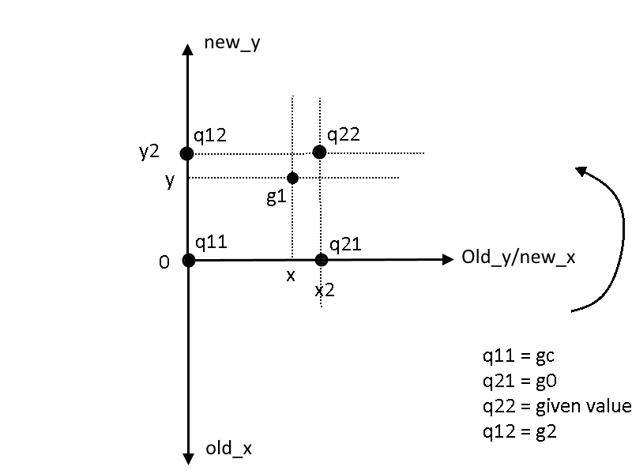

The pixel value of g1 can be interpolated using the [formulas](https://wikimedia.org/api/rest_v1/media/math/render/svg/4e0278ce632a6bae44351f3bb755bd15ecda41b4):

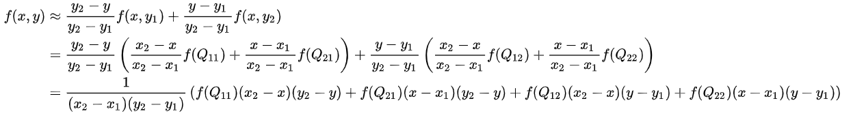

Back to the example:

[[25 41 24]

[29 33 80]

[38 56 65]]

q11 = gc = 33

q21 = 80

q22 = 24

q12 = 41

We can translate the coordinated system to the origin => this will imply that

x1=y1=0(origin point)

x2=y2=1(one pixel away from the center in both axis)

x and y values of the unknown point need to be translated into the regular coordinated system(90 degrees counterclockwise rotation, which means new_x = old_y and new_y = - old_x )

applying this formula on the unknown samples we can find :

g1 = 39 (this seems to be logically true, because it lies inside the boundaries 33 , 80, 24, 41)

g3 = 29

g5 = 39

g7 = 63

Now the threshold matrix is equal to:

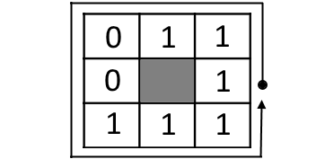

now applying the LBP formulas,

LBP = (2⁰)*1 + (2¹)*1 + (2²)*1 +(2³)*0 +(2⁴)*0 +(2⁵)*1 +(2⁶)*1+ (2⁷)*1 = 1 + 2 + 4 + 32 + 64 + 128 = 231

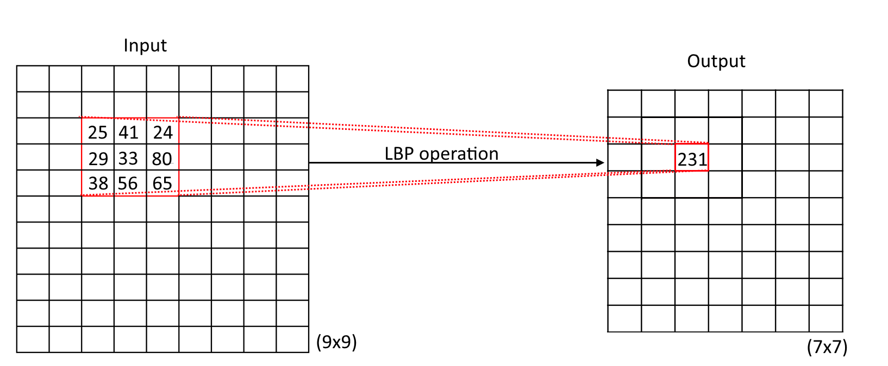

This process will repeat for each block of the image (along x and y axes)

Note that the size of the image is reduced by a factor of 2*R lines and 2*R columns like in our example we have a 9x9 image would result in a 7x7 image (R=1 for this example)

In order to find if a pixel needs an interpolation or not, we can compute the fractional part of gpx and gpy, if the fractional part for both x and y is zero(like g0, g2, g4, g6) then, the pixel lies perfectly in the center of the block, otherwise we need to do an interpolation(g1, g3, g5, g7). For this example we have 4 pixels needed to perform the bilinear interpolation, and the other four points don’t need it since the value of this pixel is already given by the matrix.

**Pseudo Code**

To implement this method in python for the purpose of the visualization of the LBP, you are required 3 for loops **:**

**For i in height range:**

**For j in width range:**

**Select a chunck of the image to compute its LBP value**

**For each block neighbours:**

**check if interpolation is needed**

**Compute_LBP(bock)**

**Add the result**

**Update the matrix with the value of LBP**

**Vectorization**

[Vectorization](https://www.geeksforgeeks.org/vectorization-in-python/#:~:text=Vectorization%20is%20used%20to%20speed,running%20time%20of%20code%20efficiently.) is the core of the internal implementation of [NumPy](https://en.wikipedia.org/wiki/NumPy). Vectorization is the absence of an explicit loop in code development. The loops themselves cannot be avoided, but their internal implementation is replaced with other constructs in the code.

The vectorization application makes the code more capacious and readable. Thanks to vectorization, many operations take a more mathematical form. For example, NumPy allows you to express the multiplication or addition of two matrices like this:

C = A*B

C = np.add(A, B, casting="unsafe")

#if A and B have two different types(like int16,float32), use casting="unsafe"

Now we can write our program using only one for loop to cycle through the neighbours’ samples

This code groups all the neighbours of the image together for each iteration of the For loop. the following illustration will clarify the mechanism of this algorithm.

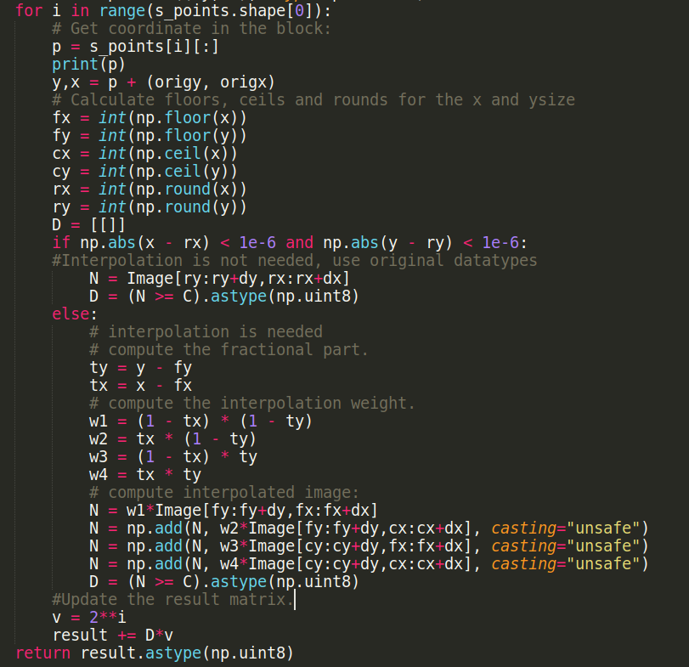

Experimental studies have shown that the application of LBP can significantly reduce time and computing costs for feature extraction.

### **5.3 Feature Extraction**

In the previous topic, we described a basic type of local descriptor(**LBP**) and how it is calculated. Now the question is:” What’s next?”

* Divide face images into R( for example R = 8 x 8 = 64 Regions) local regions to extract LBP histograms.

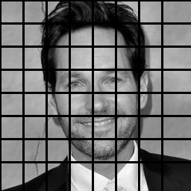

* The LBP histograms extracted from each sub-region are used for calculation and combined into a single, histogram with spatial advanced features defined as

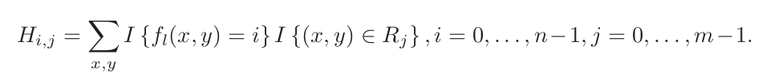

Where :

n: is the number of different labels produced by the LBP operator.

m: is the number of sub-regions.

and I{…} is defined as follow:

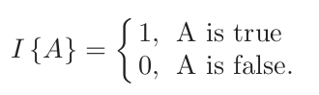

* The nearest-neighbor classifier is used to match the new image with the trained template, which is computed by one of these formulas:

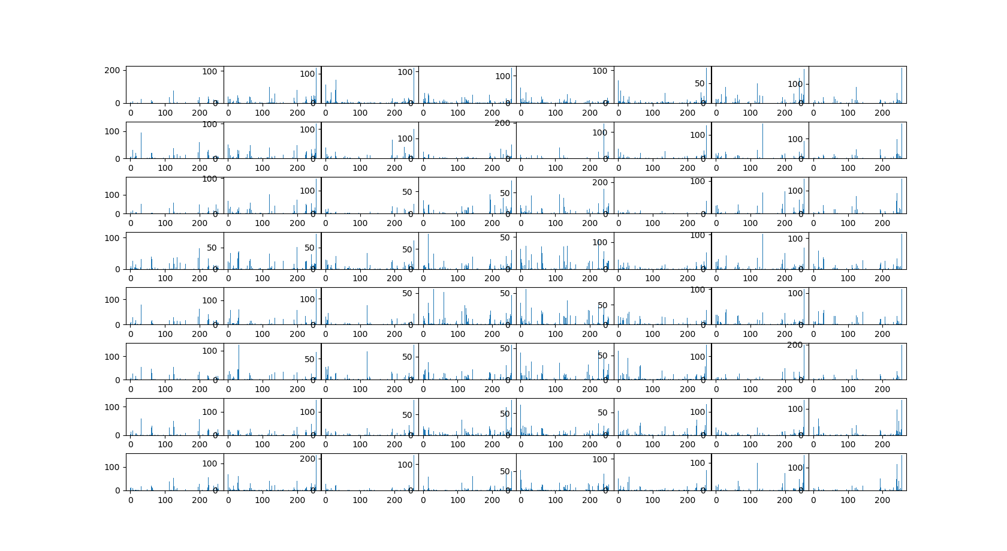

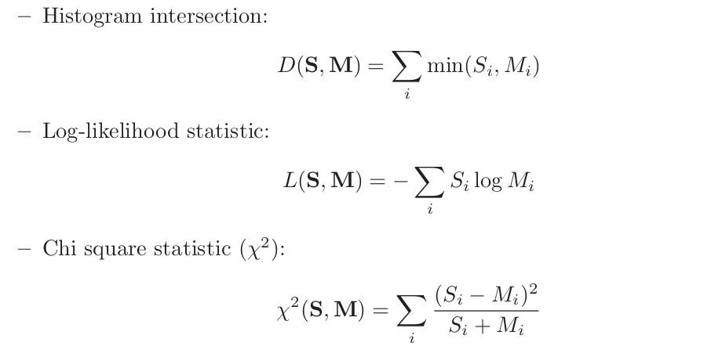where **S** and **M** are two **LBP** histograms.

The search for the best match histogram from the list can be also implemented by calculating the [Euclidean distance](https://en.wikipedia.org/wiki/Euclidean_distance#:~:text=In%20mathematics%2C%20the%20Euclidean%20distance,metric%20as%20the%20Pythagorean%20metric.) between the new and available histograms:



Next, the recognition process is as follows:

a- Adding a new image in the program for face recognition.

b- This recognizer generates an LBP histogram for the new Images.

c) Then it compares this histogram with the existing ones.

d) Finally, it finds the best match and returns the label person associated with this best match.

### **5.4 Model Training**

At this moment, it is necessary to indicate which recognition method to use in the program, namely, the method of histograms of local binary patterns. This can be implemented by the following method.

recognizer = cv2.face.LBPHFaceRecognizer_create(

int radius = 1,

int neighbors = 8,

int grid_x = 8,

int grid_y = 8)

1- **Radius**: “The radius used for building the Circular Local Binary Pattern. The greater the radius, the smoother the image but more spatial information you can get.”

2- **Neighbours**:“The number of sample points to build a Circular Local Binary Pattern. An appropriate value is to use 8 sample points. Keep in mind: the more sample points you include, the higher the computational cost.”

3- **Grid_x**: “The number of cells in the horizontal direction, 8 is a common value used in publications. The more cells, the finer the grid, the higher the dimensionality of the resulting feature vector.”

4- **Grid_y**: “The number of cells in the vertical direction, 8 is a common value used in publications. The more cells, the finer the grid, the higher the dimensionality of the resulting feature vector.”

Next, the program finds all the images in the dataset folder given the name of each image(in users_name.txt file), transforms these images into arrays, and then passes them and their ID into a recognizer for training. After that, the model creates a format file “.yaml”, containing the corresponding histograms and their labels([supervised learning](https://en.wikipedia.org/wiki/Supervised_learning#:~:text=Supervised%20learning%20is%20the%20machine,a%20set%20of%20training%20examples.)), for further recognition purposes.

**Program workflow**

We use 2 scripts in this section:

**a- data collection and training:**

python3 Train.py -v videos/video3.mkv # if you have a pre-recorded #video

python3 Train.py -c 0 # 0 is the id of the built-in camera

After capturing 30 samples, as provided in the main function, the Training stage will start:

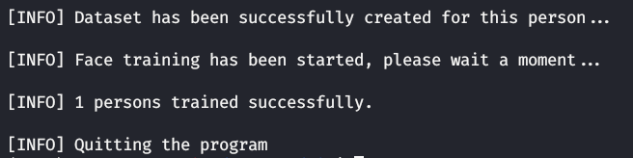

this will generate the “train.YAML” file that contains histograms and their labels:

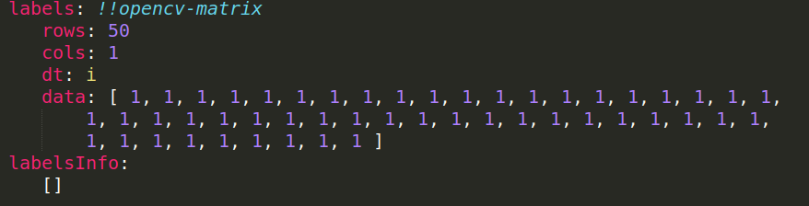

Now you can go to the main operation of the program, which is face recognition.

**Yaml Files**

YAML Ain't Mark-up Language is a data serialization language that matches user’s expectations about data. It is designed to be human friendly and works perfectly with other programming languages. It is useful to manage data and includes Unicode printable characters. This chapter will give you an introduction to YAML and gives you an idea about its features.

**Format**

Consider the text shown below −

Quick brown fox jumped over the lazy dog.

The YAML text for this will be represented as shown below −

yaml.load(Quick brown fox jumped over the lazy dog.)

>>'Quick brown fox jumped over the lazy dog.'

Note that YAML takes the value in string format and represents the output as mentioned above.

**Examples**

Let us understand the formats in YAML with the help of the following examples −

Consider the following point number of “pi”, which has a value of 3.1415926. In YAML, it is represented as a floating number as shown below −

>>> yaml.load('3.1415926536')

3.1415926536

Suppose, multiple values are to be loaded in specific data structure as mentioned below −

eggs

ham

spam

French basil salmon terrine

When you load this into YAML, the values are taken in an array data structure which is a form of list. The output is as shown below −

>>> yaml.load('''

- eggs

- ham

- spam

- French basil salmon terrine

''')

['eggs', 'ham', 'spam', 'French basil salmon terrine']

**Features**

YAML includes a markup language with important construct, to distinguish data-oriented language with the document markup. The design goals and features of YAML are given below −

* Matches native data structures of agile methodology and its languages such as Perl, Python, PHP, Ruby and JavaScript
* YAML data is portable between programming languages
* Includes data consistent data model
* Easily readable by humans
* Supports one-direction processing
* Ease of implementation and usage

Now that we have an idea about YAML and its features, let us learn its basics with syntax and other operations. Remember that YAML includes a human readable structured format.

**Rules for Creating YAML file**

When you are creating a file in YAML, you should remember the following basic rules −

* YAML is case sensitive
* The files should have .yaml as the extension
* YAML does not allow the use of tabs while creating YAML files; spaces are allowed instead

**Basic Components of YAML File**

The basic components of YAML are described below **−**

### Conventional Block Format

This block format uses hyphen+space to begin a new item in a specified list**.**

Observe the example shown below **−**

**--- # Favourite movies**

**- Casablanca**

**- North by Northwest**

**- The Man Who Wasn't There**

**Inline Format**

Inline format is delimited with comma and space and the items are enclosed in JSON. Observe the example shown below −

--- *# Shopping list*

[milk, groceries, eggs, juice, fruits]

**Folded Text**

Folded text converts newlines to spaces and removes the leading whitespace. Observe the example shown below −

- {name: John Smith, age: 33}

- name: Mary Smith

age: 27

The structure which follows all the basic conventions of YAML is shown below **−**

men: [John Smith, Bill Jones]

women:

- Mary Smith

- Susan Williams

# Chapter 6

**Face Recognition**

### **6.1 Introduction**

The task of face recognition is broad and can be tailored to the specific needs of a prediction problem. We can describe the problem of face recognition as a supervised predictive modelling task trained on samples with inputs and outputs.

In all tasks, the input is a photo that contains at least one face, most likely a detected face that may also have been aligned.

The output varies based on the type of prediction required for the task; for example:

* It may then be a binary class label or binary class probability in the case of a face verification task.
* It may be a categorical class label or set of probabilities for a face identification task.
* It may be a similarity metric in the case of a similarity type task.

**Deep Learning for Face Recognition**

Face recognition has remained an active area of research in computer vision.

Perhaps one of the more widely known and adopted “machine learning” methods for face recognition was described in the 1991 paper titled “[Face Recognition Using Eigenfaces](https://www.computer.org/csdl/proceedings/cvpr/1991/2148/00/00139758.pdf).” Their method, called simply “*Eigenfaces*,” was a milestone as it achieved impressive results and demonstrated the capability of simple holistic approaches.

Face images are projected onto a feature space (“face space”) that best encodes the variation among known face images. The face space is defined by the “eigenfaces”, which are the eigenvectors of the set of faces; they do not necessarily correspond to isolated features such as eyes, ears, and noses.

In 2018 paper titled “[Deep Face Recognition: A Survey](https://arxiv.org/abs/1804.06655),” provides a helpful summary of the state of face recognition research over the last nearly 30 years, highlighting the broad trend from holistic learning methods (such as Eigenfaces), to local handcrafted feature detection, to shallow learning methods, to finally deep learning methods that are currently state of the art. Given the breakthrough of Alex Net in 2012 for the simpler problem of image classification, there was a flurry of research and publications in 2014 and 2015 on deep learning methods for face recognition. Capabilities quickly achieved near-human-level performance, then exceeded human-level performance on a standard face recognition dataset within a three year period, which is an astounding rate of improvement given the prior decades of effort.

There are perhaps four milestone systems on deep learning for face recognition that drove these innovations; they are: DeepFace, the DeepID series of systems, VGGFace, and FaceNet. Let’s briefly touch on each.

DeepFace is a system based on deep convolutional neural networks described by Yaniv Taigman, et al. from [Facebook AI Research](https://research.fb.com/category/facebook-ai-research/) and Tel Aviv. It was described in the 2014 paper titled “[DeepFace: Closing the Gap to Human-Level Performance in Face Verification](https://ieeexplore.ieee.org/document/6909616).” It was perhaps the first major leap forward using deep learning for face recognition, achieving near human-level performance on a standard benchmark dataset.

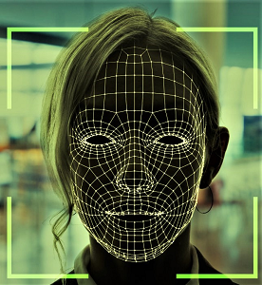

**Different persons may have very similar appearance.**

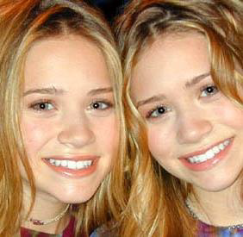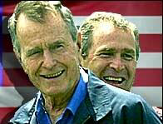

Face recognition twins and other and Son Face recognition and detection system is a pattern recognition approach for personal identification purposes in addition to other biometric approaches such as fingerprint recognition, signature, retina and so forth. The variability in the faces, the images are processed before they are fed into the network. All positive examples that is the face images are obtained by cropping images with frontal faces to include only the front view. All the cropped images are then corrected for lighting through standard algorithms.

Inter – class variability Faces with intra-subject variations in pose, illumination, expression, accessories, color, occlusions, and brightness

**Principal Component Analysis (PCA)**

Principal Component Analysis (or Karhunen-Loeve expansion) is a suitable strategy for face recognition because it identifies variability between human faces, which may not be immediately obvious. Principal Component Analysis (hereafter PCA) does not attempt to categorise faces using familiar geometrical differences, such as nose length or eyebrow width. Instead, a set of human faces is analysed using PCA to determine which 'variables' account for the variance of faces. In face recognition, these variables are called eigen faces because when plotted they display an eerie resemblance to human faces. Although PCA is used extensively in statistical analysis, the pattern recognition community started to use PCA for classification only relatively recently. As described by Johnson and Wichern (1992), 'principal component analysis is concerned with explaining the variance- covariance structure through a few linear combinations of the original variables.' Perhaps PCA's greatest strengths are in its ability for data reduction and interpretation. For example a 100x100 pixel area containing a face can be very accurately represented by just 40 eigen values. Each eigen value describes the magnitude of each eigen face in each image. Furthermore, all interpretation (i.e. recognition) operations can now be done using just the 40 eigen values to represent a face instead of the manipulating the 10000 values contained in a 100x100 image. Not only is this computationally less demanding but the fact that the recognition information of several thousand.

**Understanding Eigen Faces**

Any grayscale face image I(x,y) consisting of a NxN array of intensity values may also be considered a vector of N2. For example, a typical 100x100 image used in this thesis will have to be transformed into a 10000 dimension vector!

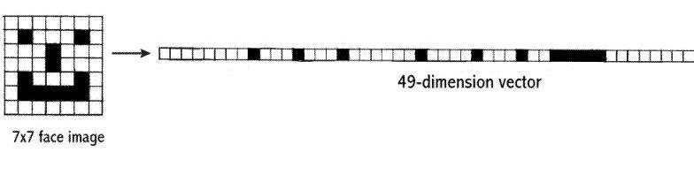

A 7x7 face image transformed into a 49 dimension vector

This vector can also be regarded as a point in 10000 dimension space. Therefore, all the images of subjects' whose faces are to be recognized can be regarded as points in 10000 dimension space. Face recognition using these images is doomed to failure because all human face images are quite similar to one another so all associated vectors are very close to each other in the 10000-dimension space.

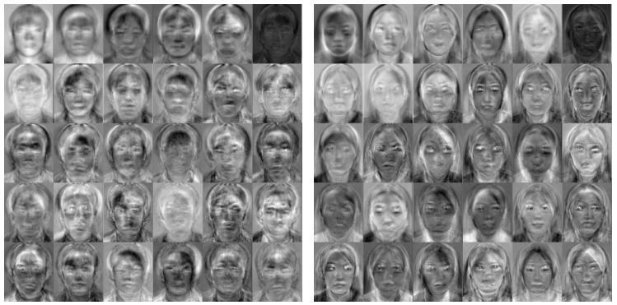

The transformation of a face from image space (I) to face space (f) involves just a simple matrix multiplication. If the average face image is A and U contains the (previously calculated) eigenfaces,

f = U * (I - A)

This is done to all the face images in the face database (database with known faces) and to the image (face of the subject) which must be recognized. The possible results when projecting a face into face space

There are four possibilities:

1. Projected image is a face and is transformed near a face in the face database

2.Projected image is a face and is not transformed near a face in the face database

3.Projected image is not a face and is transformed near a face in the face database

4. Projected image is not a face and is not transformed near a face in the face database

While it is possible to find the closest known face to the transformed image face by calculating the Euclidean distance to the other vectors, how does one know whether the image that is being transformed actually contains a face? Since PCA is a many-to-one transform, several vectors in the image space (images) will map to a point in face space (the problem is that even non-face images may transform near a known face image's faces space vector). Turk and Pentland (1991a), described a simple way of checking whether an image is actually of a face. This is by transforming an image into face space and then transforming it back (reconstructing) into image space. Using the previous notation,

I' = UT *U * (I - A

With these calculations it is possible to verify that an image is of a face and recognise that face. O'Toole et al. (1993) did some interesting work on the importance of eigen faces with large and small eigenvalues. They showed that the eigen vectors with larger eigenvalues convey information relative to the basic shape and structure of the faces. This kind of information is most useful in categorising faces according to sex, race etc. Eigen vectors with smaller eigenvalues tend to capture information that is specific to single or small subsets of learned faces and are useful for distinguishing a particular face from any other face. Turk and Pentland (1991a) showed that about 40 eigen faces were sufficient for a very good description of human faces since the reconstructed image have only about 2% RMS. pixel-by-pixel errors.

POSE INVARIANT FACE RECOGNITION

Extending the frontal view face recognition system to a pose-invariant recognition system is quite simple if one of the proposed specifications of the face recognition system is relaxed. Successful pose-invariant recognition will be possible if many images of a known individual are in the face database. Nine images from each known individual can be taken as shown below. Then if an image of the same individual is submitted within a 30o angle from the frontal view he or she can be identified.Thirty images in face database from a single known individual

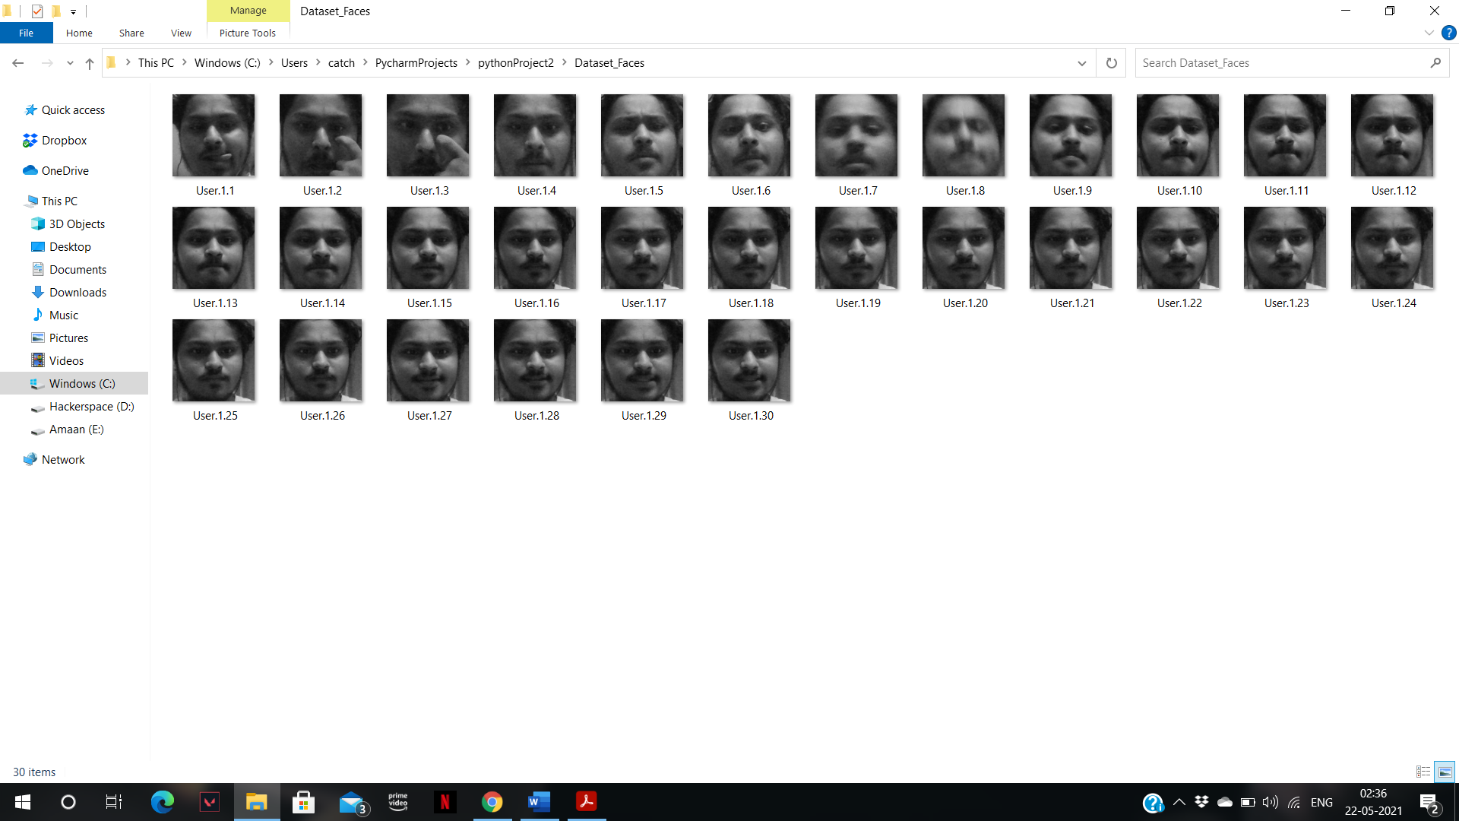 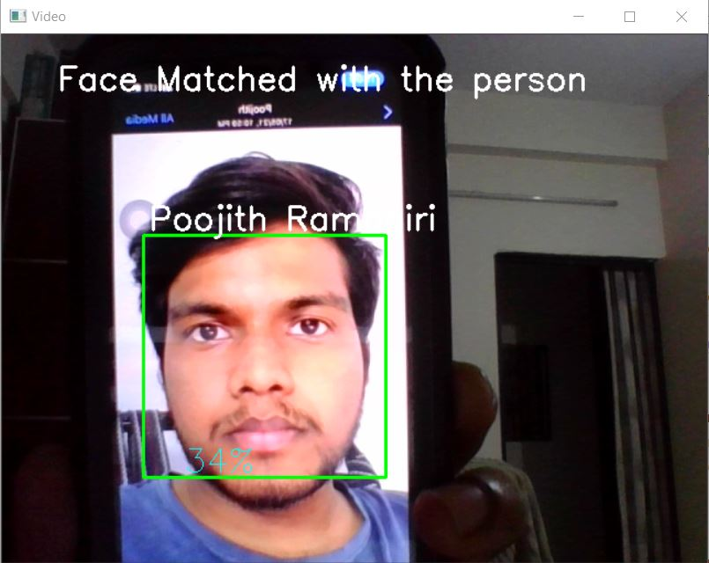

### **6.2 Application of Theft Detection**

**Introduction**

Nowadays, the home security with only door locker is not enough to protect your house and family. However the smart home security system on market still not popular for household uses because of the high price tag. Besides that, the smart home security system on market still can be improved to higher security level and build with low cost material to fulfil the need of market. Regarding to this issue, anti-theft security system using face recognition project have been started for solve this issue. It can help to solve the issues like it can trigger the alarm and capture an image send to owner when a stranger is detected in front of door. The theft will get alert so he got no time to start breaking the door and destroy the security system.

**Scope of application/Uses**

The main impact and significance of this project is to design and develop an anti-theft security system which is portable, high efficiency, low cost and easy to operate. One of the features that very useful and convenient to user is remote access control. User can control the door access with application when he not at home or even during vacation at foreign country. Furthermore, it also has the door access audit trail so user can check the record detail for during which time anyone going in your house. House owner can use this feature to track their family member and children when they come back and go in the house and their friend who enter the house also will be capture and recorded along with time log. House owner can found out the record if any incident happened and easier for track. Moreover, users no need to worry about stolen or lost key because the system is keyless. It makes our life easier and convenient users only need to input user face image data. It also increases the difficulty for theft to enter the house. Users no need to prepare a bunch of spare key for visitors who might have stay for a short period of time. Also can be used in bank lockers , atm etc.

Besides that, the door access can set the day or time restrictions. User can restrict the access. Industrials would like this features since they want their worker always have punctuality on start of work and end of work. On the same time, when the worker work for overtime their working hours can be easier with the log file.

**Working of application**

Despite of there are many similar products are available in the market, however there are still a lot of improvement can be done. The objectives of this project are:

* To design and develop an anti-theft security system which is portable, high efficiency, low cost and easy to operate.
* To detect the present of person when he or she reach in front the door and the the face recognizer will recognize the owner's face.
* To record the door access about time, user and locker status.
* To have door access time restrictions

**Exit Protection**

This system runs a timer program where the entry time and exit time of user is noted and allows user to access in certain amount of time, If user spend more time or reaches the time limit the door will be locked and sends a Alarm / warning Message to the user on the Screen. The timer program is achieved using two python modules timer & threading. The timer program helps in establishing a countdown of specified time set by the admin which when completed sends signal

to lock the door. The threading program is a module which helps in running two programs simultaneously, this is used to run the countdown program and the face recognition at the same time. The timer program provides an extra security addition and helps in developing the required application efficiently.

# Chapter 7

**Result and Discussion**

This Documentation has presented a Face Recognition (Door Unlocking) System using Machine Learning, Python and Open CV was used to implement the feature extraction and classifier, in which we used Face recognition and Machine Learning Algorithms. The prototype design for real world implementation has been elaborated, in which the output of face recognition algorithm will lock or unlock the door using a virtual simulation of door access control. This proposed system could be further developed by using hardware components such as raspberry pi and solenoid lock and can be used as security purposes for many applications in home, office, banks, industries. The loopholes which are identified in our project are further secured by OTP generation method in face storing process and in face recognition process we made the system more secure we’ve added a timer circuit to the application this make the entire face scanning time to last for a fixed amount of time.

We mainly focused on two applications which can be used in real time application.

* Biometric log registry – can be used as a Biometric system to capture people’s Entry and Exit time.
* Secured Environment Access – can be used for theft detection

Under the guidance and motivation of our beloved professor Dr.K. Krishnaveni we had successfully implemented the “door unlocking system based on facial recognition using Machine Learning” project.

**Further** **Scope**

The Project is Limited to a virtual simulation of Door Access control using Facial Recognition system in the computer itself. But we can further Extend this by implementing the hardware components in two methods.

i. By using Raspberry Pi and Solenoid Lock

ii. By using Arduino and Servo Motor

The Arduino controlled Servo Motor Method is very less secure. Hence, the working of door access control is not reliable in real time applications, because it works when Arduino gives input signal to servo, it rotates clockwise in 90 degrees and door unlocks but Raspberry pi controlled solenoid lock is very secure because it has continuous face monitoring and the working of door access works on the principle of electromagnetic theory.

**Raspberry Pi**

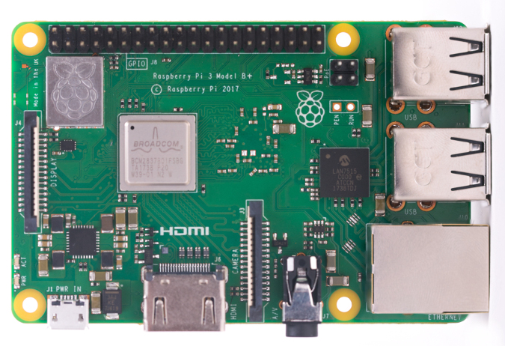

Raspberry Pi is the name of a series of single-board computers made by the [Raspberry Pi Foundation](https://www.raspberrypi.org/about/), a UK charity that aims to educate people in computing and create easier access to computing education.

The Raspberry Pi launched in 2012, and there have been several iterations and variations released since then. The original Pi had a single-core 700MHz CPU and just 256MB RAM, and the latest model has a quad-core CPU clocking in at over 1.5GHz, and 4GB RAM. The price point for Raspberry Pi has always been under $100 (usually around $35 USD), most notably the Pi Zero, which costs just $5.

All over the world, people use the Raspberry Pi to learn programming skills, build hardware projects, do home automation, [implement Kubernetes clusters](https://opensource.com/article/20/6/kubernetes-raspberry-pi) and [Edge computing](https://enterprisersproject.com/article/2019/7/edge-computing-explained-plain-english), and even use them in industrial applications.

The Raspberry Pi is a very cheap computer that runs Linux, but it also provides a set of GPIO (general purpose input/output) pins, allowing you to control electronic components for physical computing and explore the Internet of Things (IoT).

**Solenoid Lock**

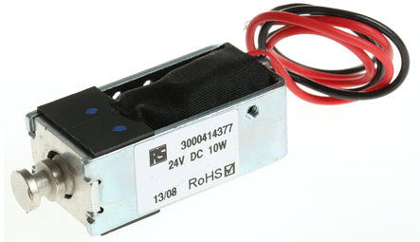

The solenoids are simple [electrical components](https://www.elprocus.com/basic-components-used-electronics-electrical/) and have many uses in daily life. The term itself is derived from the Greek name “solen”, which illustrates a channel or a pipe. The second part of the name is taken from the Greek name “eidos”, which refers to an outline. Basically, it is a component in the form of a pipe. The solenoid is used in a variety of applications, and there are numerous types of solenoid designs available. Each of them has their own properties that make it useful in many precise applications. The various designs of these components do not change their necessary operating features and the designing of the solenoids can be done in different ways. Generally, solenoid works on general electrical principle, but the mechanical energy of this device is distributed in a different way in different designs.

A solenoid is a very simple component that includes a coil of wire that is covered around a core made out of a metal. When a current is applied to the solenoid, it has the effect of assembling a consistent magnetic field. Electricity changes to magnetism then it changes to electricity and, therefore, these two forces are united into one.

An attractive thing about the uniform field in a solenoid is that, if the solenoid has an immeasurable length, the magnetic field would be similar everywhere along the element. In a solenoid, sometimes this translates to very small electrical components being able to do a marvellous amount of work. For instance, a powerful solenoid can simply slam shut a valve that would be demanding for even the burliest plumber to close by hand.

**Arduino**

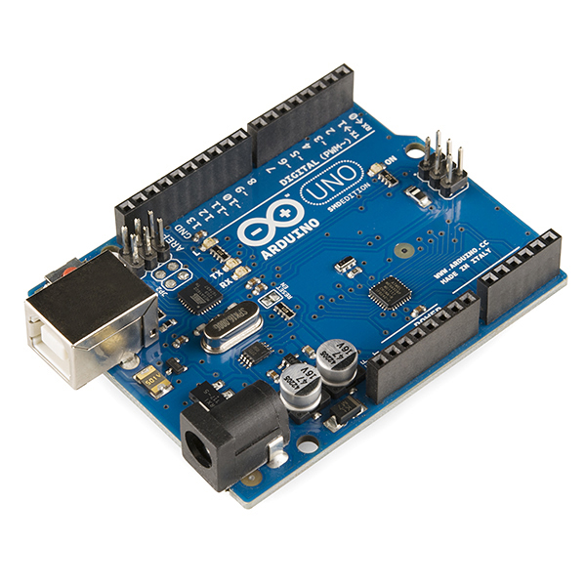

Arduino is an open-source electronics platform based on easy-to-use hardware and software. [Arduino boards](https://www.arduino.cc/en/Main/Products) are able to read inputs - light on a sensor, a finger on a button, or a Twitter message - and turn it into an output - activating a motor, turning on an LED, publishing something online. You can tell your board what to do by sending a set of instructions to the microcontroller on the board. To do so you use the [Arduino programming language](https://www.arduino.cc/en/Reference/HomePage) (based on [Wiring](http://wiring.org.co/)), and the Arduino software.

Over the years Arduino has been the brain of thousands of projects, from everyday objects to complex scientific instruments. A worldwide community of makers - students, hobbyists, artists, programmers, and professionals - has gathered around this open-source platform, their contributions have added up to an incredible amount of [accessible knowledge](http://forum.arduino.cc/) that can be of great help to novices and experts alike.

Arduino was born at the Ivrea Interaction Design Institute as an easy tool for fast prototyping, aimed at students without a background in electronics and programming. As soon as it reached a wider community, the Arduino board started changing to adapt to new needs and challenges, differentiating its offer from simple 8-bit boards to products for IoT applications, wearable, 3D printing, and embedded environments. All Arduino boards are completely open-source, empowering users to build them independently and eventually adapt them to their particular needs. The [software](https://www.arduino.cc/en/Main/Software), too, is open-source, and it is growing through the contributions of users worldwide.

**Servo Motor**

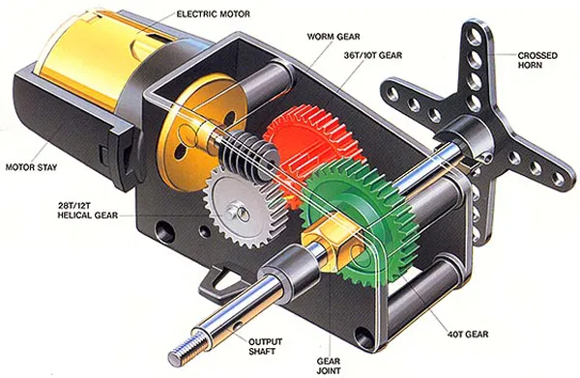

A servo motor is a type of motor that can rotate with great precision. Normally this type of motor consists of a control circuit that provides feedback on the current position of the motor shaft, this feedback allows the servo motors to rotate with great precision. If you want to rotate an object at some specific angles or distance, then you use a servo motor. It is just made up of a simple motor which runs through a servo mechanism. If a motor is powered by a DC power supply then it is called DC servo motor, and if it is AC-powered motor then it is called AC servo motor. For this tutorial, we will be discussing only the DC servo motor working. Apart from these major classifications, there are many other types of servo motors based on the type of gear arrangement and operating characteristics. A servo motor usually comes with a gear arrangement that allows us to get a very high torque servo motor in small and lightweight packages. Due to these features, they are being used in many applications like toy car, RC helicopters and planes, Robotics, etc

A servo consists of a Motor (DC or AC), a potentiometer, gear assembly, and a controlling circuit. First of all, we use gear assembly to reduce RPM and to increase torque of the motor. Say at the initial position of the servo motor shaft, the position of the potentiometer knob is such that there is no electrical signal generated at the output port of the potentiometer. Now an electrical signal is given to another input terminal of the error detector amplifier. Now the difference between these two signals, one comes from the potentiometer and another comes from other sources, will be processed in a feedback mechanism and output will be provided in terms of error signal. This error signal acts as the input for the motor and motor starts rotating. Now the motor shaft is connected with the potentiometer and as the motor rotates so does the potentiometer and it will generate a signal. So as the potentiometer’s angular position changes, its output feedback signal changes. After sometime the position of potentiometer reaches a position that the output of potentiometer is the same as the external signal provided. At this condition, there will be no output signal from the amplifier to the motor input as there is no difference between external applied signal and the signal generated at potentiometer, and in this situation the motor stops rotating.

It is a closed-loop system where it uses a positive feedback system to control motion and the final position of the shaft. Here the device is controlled by a feedback signal generated by comparing output signal and reference input signal.

Here the reference input signal is compared to the reference output signal and the third signal is produced by the feedback system. And this third signal acts as an input signal to control the device. This signal is present as long as the feedback signal is generated or there is a difference between the reference input signal and reference output signal.

**Face Recognition Door Lock System Using Raspberry pi and Solenoid Lock**

Face Recognition technology has improved drastically in the past decade and now it is primarily used for surveillance and security purposes. In this Section, we demonstrate the Face Recognition Door Lock System using Raspberry Pi. This project consists of three phases:

1. Data Gathering
2. Training the Recognizer
3. Face Recognition

In the first phase, we will collect the face samples that are authorized to open the lock. In the second phase, we will train the Recognizer for these face samples, and in the last phase, trainer data will be used to recognize the faces. If raspberry pi recognizes a face, it will open the door lock.

Here, a solenoid lock and a Pi camera will be used with Raspberry Pi to build this **face recognition-based door lock system using Raspberry Pi 3**. The use of [solenoid lock with Raspberry pi](https://iotdesignpro.com/projects/iot-based-solenoid-door-lock-using-raspberry-pi-4), can also built a few projects with Pi camera like [Web Controlled Raspberry Pi Surveillance Robot](https://iotdesignpro.com/projects/web-controlled-raspberry-pi-surveillance-robot), [IoT based Smart Wi-Fi doorbell](https://iotdesignpro.com/projects/iot-based-smart-wifi-doorbell-using-raspberry-pi-and-picamera), [Smart CCTV Surveillance System](https://iotdesignpro.com/projects/smart-cctv-surveillance-system-using-raspberry-pi), etc.

**Components Required:**

* Raspberry Pi 3 (any version)
* Solenoid Lock
* Relay Module
* Jumper Wires

**Circuit Diagram:**

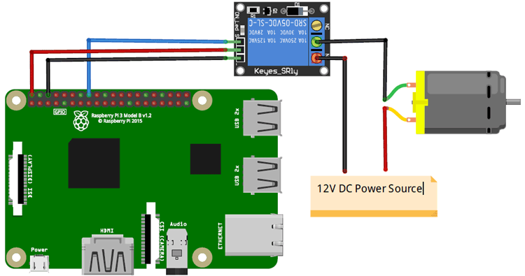

The [GPIO pins of the Raspberry Pi](https://maker.pro/raspberry-pi/projects/gpio-controlling-of-the-raspberry-pi) can give an output of 3.3V but the solenoid lock requires 7-12V to operate. Because of this, we will need to use an external power source and relay to operate the lock. Connect the VCC and GND of the relay module to 5V and GND of Raspberry Pi. Then connect the signal pin of the relay module to the GPIO 26 of Raspberry Pi.

On the other side of the relay module, connect the negative form DC power source to the negative of the solenoid door lock. Connect the positive from the DC power source to the common of the relay module and then connect normally open from the relay module to the positive of the solenoid door lock.

Raspberry Pi and Solenoid Lock are connected through the relay module. Solenoid lock requires 9 to 12V, and Raspberry pi can provide only 5V. Due to this, a 12V adapter is used to power the Solenoid Lock. The VCC and GND pin of the relay module is connected to 5V and GND of Raspberry Pi. The input pin of the relay is connected to GPIO23 of Raspberry Pi.

The positive pin of Solenoid lock is connected to the positive rail of the 12V adapter, while the negative pin of Solenoid Lock is connected to COM of Relay. Connect the NO pin of the relay to Negative of 12V adapter

The breadboard setup for **Raspberry Pi 3 Face Recognition Door Lock** is shown below:

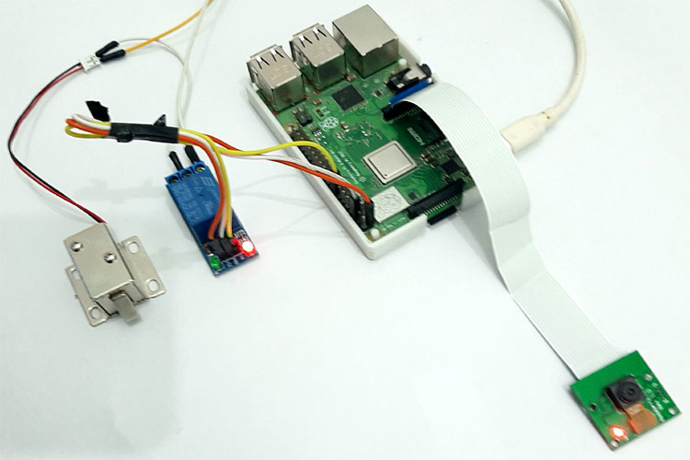

**Installing OpenCV in Raspberry Pi 3**

Here OpenCV library is used to detect and recognize faces. To install the OpenCV, first, update the Raspberry Pi.

**sudo apt-get update**

Then use the following commands to install the required dependencies for installing OpenCV on your Raspberry Pi.

sudo apt-get install libhdf5-dev -y

sudo apt-get install libhdf5-serial-dev –y

sudo apt-get install libatlas-base-dev –y

sudo apt-get install libjasper-dev -y

sudo apt-get install libqtgui4 –y

sudo apt-get install libqt4-test –y

After that, use the below command to install the OpenCV on your Raspberry Pi.

pip3 install opencv-contrib-python==4.1.0.25

Installing other Required Packages for Face Recognition

Before beginning the program for Face Recognition Door Lock System using Raspberry Pi, let’s install the required packages.

Installing *dlib*: dlib is the modern toolkit that contains Machine Learning algorithms and tools for real-world problems. Use the below command to install the dlib.

pip3 install dlib

Installing face_recognition module: This library used to recognize and manipulate faces from Python through the command line. Use the below command to install the face recognition library.

Pip3 install face_recognition

Installing imutils: imutils is used to make essential image processing functions such as translation, rotation, resizing, skeletonization, and displaying Matplotlib images easier with OpenCV. Use the below command to install the imutils:

pip3 install imutils

Installing pillow: Pillow is used to open, manipulate, and save images in a different format. Use the below command to install pillow:

pip3 install pillow

**Programming for Raspberry Pi Face Recognition Door Lock**

As mentioned earlier, we are going to complete this project in three-phase. The first phase is data gathering; the second is training the Recognizer, and the third is recognizing the faces. Programs for all three sections are given at the end. Here we have explained each one of them in detail.

**1. Data Gathering**

In the first phase of the project, create a Dataset to store the faces. These faces will be stored with different IDs.

For that, first, create a project directory where all the project data will be saved.

**mkdir Face Recognition**

Besides the three python programs and Dataset, this directory also has a **Facial Classifier file**. All three python programs and Facial Classifier file is given at the end of the page.

Now inside theFaceRecognitionProjec*t* directory, create a new subdirectory named **Dataset** to store the face samples.

**mkdir Dataset**

Now open a *Nano* editor file in ***FaceRecognitionProject*** directoryand paste the data gathering program given at the end.

**sudo nano dataset.py**

Data Gathering program is explained below:

Initialize the face detector. The facial classifier file is used with a face detector.

face_detector = cv2.CascadeClassifier('haarcascade_frontalface_default.xml')

Now provide a user input command so that the user can enter the numeric face id before gathering the data.

face_id = input('\n enter user id end press ENTER ==> ')

Inside the *while* loop, use the detector to extract the faces.

ret, img = cam.read()

img = cv2.flip(img, -1) # flip video image vertically

gray = cv2.cvtColor(img, cv2.COLOR_BGR2GRAY)

faces = face_detector.detectMultiScale(gray, 1.3, 5)

After that, save the each one of the captured frames, save it as a file on a "*dataset*" directory with the person id:

cv2.imwrite("dataset/User." + str(face_id) + '.' + str(count) + ".jpg", gray[y:y+h,x:x+w])

Run the python scripts and enter the face id. When it detects a face, it starts capturing the samples. These samples will be saved inside the *Dataset* directory.

This is how the **directories and program files will be structured**:

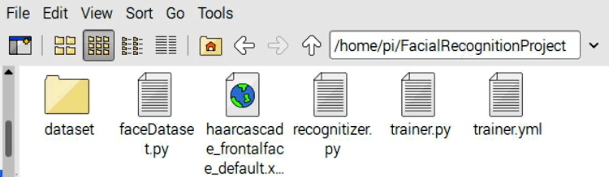

**2. Training the Recognizer**

After gathering the face samples, train the Recognizer for these samples so that it can predict the faces accurately.

Open a Nano editor file inside the *FaceRecognition* directory, paste the trainer code (given at the end) and save it as trainer.py

Python script for training the Recognizer is explained below:

Start the code by importing all the required library files.

import cv2

import numpy as np

from PIL import Image

import os

After that, enter the path where you saved the face samples.

path = 'dataset'

Next, use the haarcascade_frontalface_default.xml facial classifier file to detect the faces in sample images. Then use the recognizer variable to create an LBPH (Local Binary Pattern Histogram) Face Recognizer**.**

detector = cv2.CascadeClassifier("haarcascade_frontalface_default.xml");

recognizer = cv2.face.LBPHFaceRecognizer_create()

Now get into the face samples directory using the path that is initialized earlier.

imagePaths = [os.path.join(path,f) for f in os.listdir(path**)]**

After that, create two lists for storing face samples and IDs.

faceSamples=[]

ids = []

Convert the image samples into grayscale. After that, convert the PIL image into a numpy image.

PIL_img = Image.open(imagePath).convert('L') # convert it to grayscale

img_numpy = np.array(PIL_img,'uint8')

Sample in the Dataset directory is saved like this: User.Id.SampleNumber. So to get the ID, we will split the image path. By splitting the image path, we will get a User ID, and sample number.

id = int(os.path.split(imagePath)[-1].split(".")[1])

Now call the Faces and IDs list and feed them into the trainer file.

faces,ids = getImagesAndLabels(path)

recognizer.train(faces, np.array(ids))

**3. Recognizer**

Now in the final step of our project, we will use face recognition technology to recognize faces from the live video feed. Once raspberry pi recognizes any saved face, it will make the relay module high to open the solenoid lock.

The complete face recognition program is given at the end of the page. Some important parts of this code are explained below:

This program is similar to the trainer program, so use the same library files and also the classifier file.

After that, use an array to add the name for each face id.

names = ['None', 'Ashish', 'Thor']

Now obtain video feed from the raspberry pi camera in 640x480 resolution. If you are using more than one camera, then replace zero with one in cam = cv2.VideoCapture(0) function

cam = cv2.VideoCapture(0)

cam.set(3, 640) # set video width

cam.set(4, 480) # set video height

After that, inside the *while* loop, break the video into images and then convert it to grayscale**.**

ret, img =cam.read()

img = cv2.flip(img, -1) # Flip vertically

gray = cv2.cvtColor(img,cv2.COLOR_BGR2GRAY)

Use recognizer.predict function to check how much the face matches with the samples.

cv2.rectangle(img, (x,y), (x+w,y+h), (0,255,0), 2)

id, confidence = recognizer.predict(gray[y:y+h,x:x+w])

If confidence is less than 100, then open the lock. 0 means the perfect match.

if (confidence < 100):

id = names[id]

confidence = " {0}%".format(round(100 - confidence))

GPIO.output (relay, 1)

**Face Recognition Door Lock System using Arduino and Servo Motor**

When it comes to innovation using the internet, among thousands of platforms and tools available to us, a couple that stand out are Arduino and Bolt IoT. In this project, we'll modify a standard shelf to have a security system that unlocks using Face Verification. We'll build a Windows Forms Application in C# that can store, verify and unlock trusted faces. It uses [FacePlusPlus API](https://www.faceplusplus.com/) for face verification and [Bolt IoT Cloud API](https://cloud.boltiot.com/apiDoc) for communicating with Bolt WiFi Module and Arduino. We'll interface the Bolt WiFi Module with an Arduino Uno, that'll control a servo motor to lock/unlock the door.

**Building the Software**

We'll build a Windows Forms Application using Visual Studio. This application runs on a Windows machine, and will be responsible for managing authorized faces, verifying a face using FacePlusPlus API and communicating with the Bolt WiFi Module. We'll be using C# to code.

Fire up Visual Studio and create a new Windows Forms Application project. If you are completely new to Visual Studio, I recommend learning the basics of Windows Forms Application Development using Visual Studio. [This](https://docs.microsoft.com/en-us/visualstudio/ide/step-1-create-a-windows-forms-application-project?view=vs-2017) and [this](https://www.geeksforgeeks.org/introduction-to-c-sharp-windows-forms-applications/) are good resources to get started.

Our Visual Studio project makes use of 3 libraries for various purposes. They are:

* [AForge .NET](http://www.aforgenet.com/framework/tools/): A popular .NET framework used for image processing in Windows. We use it for capturing images from a webcam.
* [Bolt IoT API .NET](https://github.com/diozz/Bolt-IoT-API-.NET/): An unofficial client library that I wrote in C#, for communicating the Bolt Cloud API.
* [Newtonsoft JSON](https://github.com/JamesNK/Newtonsoft.Json): A popular high-performance JSON framework for .NET. Used for parsing API responses in our project.

Before jumping into coding, we need to set a few things up.

1. Bolt Cloud API Credentials

If you haven't already, go to [cloud.boltiot.com](https://cloud.boltiot.com/register/) and set up an account. Once you're logged in, link your WiFi Module with the Bolt Cloud. For that, download the Bolt IoT Setup App on your mobile phone. Follow the instructions given in the app to link your device with your account. This involves pairing the Bolt with the local WiFi network. Once successfully linked, your dashboard will display your device. You can now get your Device ID and an API Key from the dashboard.

2. FacePlusPlus API Credentials

Another API service that we rely on in this project is *FacePlusPlus API*. It's a free platform that offers various kinds of image recognition services. We use it for facial identification. [Create an account](https://console.faceplusplus.com/register) and go to the FacePlusPlus console. Go to API Key under Apps and click on +Get API Key. Note down the newly generated API Key and API Secret.

Now you should have the following ready:

private readonly string BOLT_DEVICE_ID = "BOLTXXXXXX";

private readonly string BOLT_API_KEY = "XXXXXXXXXXXXXXXXXXXXXXXXXXXXXX";

private readonly string FPP_API_KEY = "XXXXXXXXXXXXXXXXXXXXXXXXXXXXXXXXXXX";

private readonly string FPP_API_SECRET = "XXXXXXXXXXXXXXXXXXXXXXXXXXXXXXX";

We create a new global instance of the Bolt class called myBolt, through which we'll do all the future communications with the WiFi Module:

myBolt = new Bolt(BOLT_API_KEY, BOLT_DEVICE_ID);

That said, now let's see how our application performs some of the core functions

**Lock/Unlock Door**

We have designed the circuit such that when Digital Pin 0 is HIGH, the door is supposed to get locked, and when Digital Pin 3 is HIGH, door's supposed to be unlocked. This'll be made more clear later when we discuss the circuit schematics.

For locking, we use the [DigitalMultiWrite](https://github.com/diozz/Bolt-IoT-API-.NET#digitalmultiwrite) method from library to write HIGH value to D0 and LOW value to D3. This will signal the Arduino to lock the door. Similarly for unlocking, we'll write LOW value to D0 and HIGH value to D3. This will signal the Arduino to unlock the door. We'll discuss the Arduino code and circuit design later in this tutorial.

Code that performs locking:

private async Task LockDoor()

{

MultiPinConfig multiPinConfig = new MultiPinConfig();

MultiPinConfig.AddPinState(DigitalPins.D0, DigitalStates.High); //Lock Signal

multiPinConfig.AddPinState(DigitalPins.D3, DigitalStates.Low); //unlock Signal

await myBolt.DigitalMultiWrite(multiPinConfig);

multiPinConfig = new MultiPinConfig();

multiPinConfig.AddPinState(DigitalPins.D0, DigitalStates.Low); //Lock Signal

multiPinConfig.AddPinState(DigitalPins.D3, DigitalStates.Low); //Unlock Signal

await myBolt.DigitalMultiWrite(multiPinConfig);

}

Code that performs unlocking:

private async Task UnlockDoor()

{

MultiPinConfig multiPinConfig = new MultiPinConfig();

multiPinConfig.AddPinState(DigitalPins.D0, DigitalStates.Low); //Lock Signal

multiPinConfig.AddPinState(DigitalPins.D3, DigitalStates.High); //Unlock Signal

await myBolt.DigitalMultiWrite(multiPinConfig);

multiPinConfig = new MultiPinConfig();

multiPinConfig.AddPinState(DigitalPins.D0, DigitalStates.Low); //Lock Signal

multiPinConfig.AddPinState(DigitalPins.D3, DigitalStates.Low); //Unlock Signal

await myBolt.DigitalMultiWrite(multiPinConfig)

**Add/Remove Trusted Faces**

The trusted face's image data is encoded into a Base64 string and is stored locally in the machine. A list of corresponding names of each face is also stored. In our program, to add a face, we first verify if there is a face available in the current frame. We do this using the [Detect API](https://console.faceplusplus.com/documents/5679127) of FacePlusPlus. It returns a JSON response that will contain features of the detected face. If no face is detected the response will simply be []. Once a face is detected, we save the image's base64 encoded string and corresponding name. Here's a video demo of adding a trusted face

Removing a face is pretty straight forward. Pressing the remove button will delete the image data and name from the saved list.

Code that adds and saves the face information:

//Converting image to base64 string and adding it to the list.

ImageDataList.Add(ImageToBase64((Image)PreviewBox.Image.Clone()));

//Adding name of the face to the list

NameList.Add(FaceNameTextBox.Text.Trim());

//Saves the face image data as a base encoded string, along with its name

Properties.Settings.Default.Base64ImageData = ImageDataList;

Properties.Settings.Default.FaceNames = NameList;

Properties.Settings.Default.Save();

Code that removes a face information:

//Removing face information at specified position in the list

NameList.RemoveAt(e.RowIndex);

ImageDataList.RemoveAt(e.RowIndex);

//Saving the the list after removal of a face

Properties.Settings.Default.FaceNames = NameList;

Properties.Settings.Default.Base64ImageData = ImageDataList;

Properties.Settings.Default.Save();

Check out the code in the attached project where the process is explained as comments in each line for having a clear idea.

**Face Verification**

We verify if a face is trusted or not by using the [Compare API](https://console.faceplusplus.com/documents/5679308) in FacePlusPlus. During this process, we linearly iterate through each face in the saved list and compare it with the captured image. If the API returns a confidence of more than 80%, we'll unlock the door.

The code that does this comparison looks something like this:

WebClient client = new WebClient();

byte[] response = client.UploadValues("https://api-us.faceplusplus.com/facepp/v3/compare", new NameValueCollection()

{

{ "api_key", FPP_API_KEY },

{ "api_secret", FPP_API_SECRET },

{ "image_base64_1", face1Base64},

{ "image_base64_2", face2Base64}

});

});

String confidence = JObject.Parse(System.Text.Encoding.UTF8.GetString(response))["confidence"].ToString();

[*WebClient.UploadValues*](https://docs.microsoft.com/en-us/dotnet/api/system.net.webclient.uploadvalues?view=netframework-4.7.2) method sends the request to FacePlusPlus API along with the base64 encoded face data of two faces to be compared and our API credentials. The response is parsed using *Newtonsoft JSON* library and *confidence* value is obtained. Read the Compare API [documentation](https://console.faceplusplus.com/documents/5679308) for understanding the arguments clearly.

**The Bell Listening Thread**

We plan to provide a physical push button, something like a calling bell button, so that the user can press while looking at the camera to unlock the door. To make this possible, we need to create a new dedicated thread that continuously listens for the bell button press event.

Later in this tutorial, we'll see how the push button is employed and how it will make the D4 pin of Bolt WiFi module HIGH when the button is pressed. For now, we'll just assume the above. So in this thread, we continuously [DigitalRead](https://github.com/diozz/Bolt-IoT-API-.NET#digitalread) the value of the D4 pin. If it's HIGH, we'll take that as a bell ring event and do the face capture and verification.

Here's the code that'll run continuously on the bell listening thread:

while (ListenForBell)

{

Response R = await myBolt.DigitalRead(DigitalPins.D4);

if (R.Value == "1")

{

RingBell_Click(null, null);

Thread.Sleep(2000);

}

Thread.Sleep(2000);}

We stop and wait for 2 seconds between each iteration. Otherwise it'll exhaust Bolt Cloud API's usage quota quickly.

**Circuit Design and Arduino Code**

In the circuit, intended to implement the following features:

* Red and Green LED indication for locked and unlocked door states, respectively.
* A push button to act like a calling bell switch. When pressed, our WinForms application should verify face and open the door upon successful face authentication.
* Another push button to lock the door.
* A buzzer that beeps in the event of a doorbell ring and door lock.

The circuit connection of our project is shown below:

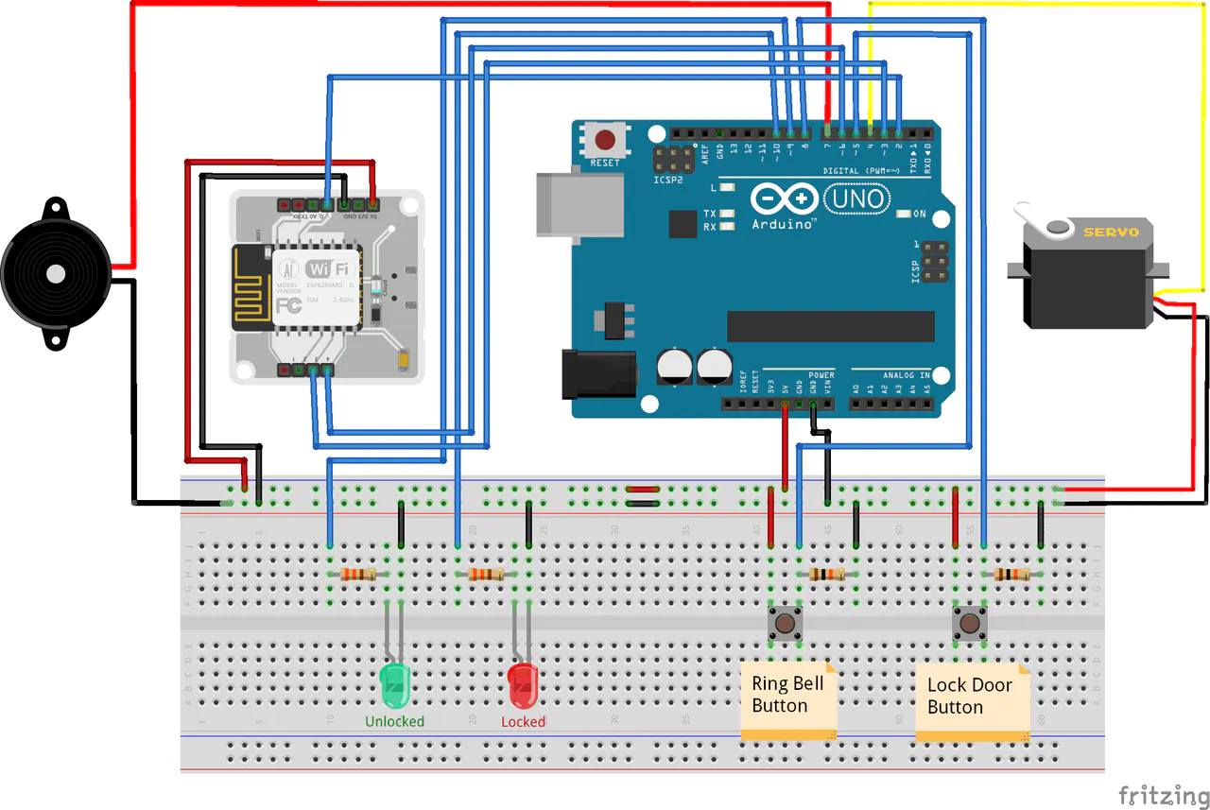

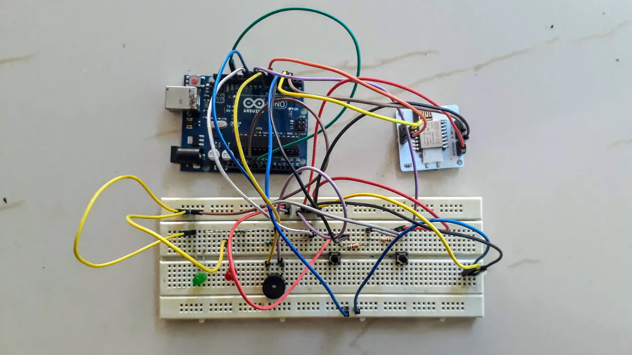

if you haven't already, download the Arduino IDE from [here](https://www.arduino.cc/en/main/software) and connect your Arduino to the system. Make sure you've set the right Arduino model and Port in the IDE settings, before uploading the code.

**Arduino Code**:

#include <Servo.h>

#define ServoPin 4

#define LockSignalPin 2

#define UnLockSignalPin 3

#define BellButtonPin 5

#define LockButtonPin 8

#define RingBellSignalPin 6

#define BuzzerPin 7

#define GreenLedPin 9

#define RedLedPin 10

Servo myServo;

void setup()

{

pinMode(LockSignalPin, INPUT);

pinMode(UnLockSignalPin, INPUT);

pinMode(BellButtonPin, INPUT);

pinMode(LockButtonPin, INPUT);

pinMode(BuzzerPin, OUTPUT);

pinMode(RedLedPin, OUTPUT);

pinMode(GreenLedPin, OUTPUT);

pinMode(RingBellSignalPin, OUTPUT);

digitalWrite(RedLedPin, LOW);

digitalWrite(GreenLedPin, LOW);

digitalWrite(RingBellSignalPin, LOW);

myServo.attach(ServoPin);

Serial.begin(9600);

}

void loop()

{

int lockButton, lock, unlock, bell;

char snum[5];

lock = digitalRead(LockSignalPin);

unlock = digitalRead(UnLockSignalPin);

// Check if lock signal from Bolt is HIGH

if(lock == HIGH)

{

// Turn motor to locked position

myServo.write(120);

// Set LED indications

digitalWrite(GreenLedPin, LOW);

digitalWrite(RedLedPin, HIGH);

// Buzz locking sound

digitalWrite(BuzzerPin, HIGH);

delay(1000);

digitalWrite(BuzzerPin, LOW);

delay(1000);

}

// Check if unlock signal from Bolt is HIGH

else if(unlock == HIGH)

{

// Turn motor to unlocked position

myServo.write(0);

// Set LED indications

digitalWrite(GreenLedPin, HIGH);

digitalWrite(RedLedPin, LOW);

delay(2000);

}

bell = digitalRead(BellButtonPin);

if(bell == HIGH) // User pressed bell ring betton

{

// Signal Bolt that ring button was pressed

digitalWrite(RingBellSignalPin, HIGH);

// A calling bell sound pattern !

digitalWrite(BuzzerPin, HIGH);

delay(100);

digitalWrite(BuzzerPin, LOW);

delay(20);

digitalWrite(BuzzerPin, HIGH);

delay(200);

digitalWrite(BuzzerPin, LOW);

delay(100);

digitalWrite(BuzzerPin, HIGH);

delay(100);

digitalWrite(BuzzerPin, LOW);

delay(20);

digitalWrite(BuzzerPin, HIGH);

delay(200);

digitalWrite(BuzzerPin, LOW);

delay(1500);

// Turn off the signal

digitalWrite(RingBellSignalPin, LOW);

}

lockButton = digitalRead(LockButtonPin);

if(lockButton == HIGH) // User pressed lock betton

{

// Turn motor to locked position

myServo.write(120);

// Set LED indications

digitalWrite(GreenLedPin, LOW);

digitalWrite(RedLedPin, HIGH);

// Buzz locking sound

digitalWrite(BuzzerPin, HIGH);

delay(1000);

digitalWrite(BuzzerPin, LOW);

}

}

**Conclusion**

At first the python code will be write on any of the python IDE than arduino code will be uploaded to arduino Uno board using arduino IDE and then Run the 1st python code it will collect the sample pictures and then run 2nd code and it will start the webcam and take pictures , if the picture match with database upto 83% then it will send a character to the arduino and arduino will move the servo motor for 5 seconds.

# References

[1] Y. Januzaj, A. Luma, Y. Januzaj, V. Ramaj., "Real time access control based on face recognition," in International Conference on Network security & Computer Science (ICNSCS-15), pp. 7-12, 2015.

[2] M. Sahani, C. Nanda, A. K. Sahu, B. Pattnaik., "Home security system based on face recognition,"" 2015 Int. Conf. Circuits, Power Comput. Technol. [ICCPCT-2015], pp. 1–6, 2015.

[3] G. Senthilkumar, K. Gopalakrishnan, V. S. Kumar., “Embedded image capturing system using raspberry pi system,” vol. 3, No. 2, pp. 213-215, 2014.

[4] M. R. Mulla., "Facial image-based security system using PCA," pp. 548-553, 2015.

[5] M. H. Jusoh & F. Bin Jamali, ''Home security system using internet of things,'' 2017.

[6] S. S. Liew, M. Khalil-Hani, S. Ahmad Radzi, R. Bakhteri., ''Gender classification: A convolutional neural network approach,'' Turkish J. Electr. Eng. Comput. Sci., vol. 24, No. 3, pp. 1248-1264, 2016.

[7] M. Sajjad et al., ''Raspberry pi assisted face recognition framework for enhanced law-enforcement services in smart cities,'' Future. Gener. Comput. Syst., 2017.

[8] A. R. Syafeeza, S. S. Liew, R. Bakhteri., ‘'Convolutional neural networks with fused layers applied to face recognition,'' Int. J. Comput. Intell. Appl., vol. 14, No. 3, 2015.

[9] A. R. Syafeeza, M. Khalil-Hani, S. S. Liew, R. Bakhteri., ''Convolutional neural network for face recognition with pose and illumination variation,'' Int. J. Eng. Technol., Vol. 6, No. 1, pp. 44-57, 2014.

[10] K. Syazana-Itqan, A. R. Syafeeza, N. M. Saad, N. A. Hamid, W. H. Bin Mohd Saad., ''A review of finger-vein biometrics identification approaches,'' Indian J. Sci. Technol., vol. 9, No. 32, 2016.

[11] S. Ahmad Radzi, M. Khalil-Hani, R. Bakhteri., ''Finger-vein biometric identification using convolutional neural network,'' Turkish J. Electr. Eng. Comput. Sci., vol. 24, No. 3, pp. 1863-1878, 2016.

[12] S. Ahmad Radzi., ‘'A MATLAB-based convolutional neural network approach for face recognition system,” J. Bioinforma. Proteomics Rev, vol. 2(1), pp. 1-5, 2016.

[13] M. K. M. F. Alif, A. R. Syafeeza, P. Marzuki, A. N. Alisa., ‘'Fused convolutional neural network for facial expression recognition,’ ‘in Symposium on Electrical, Mechatronics and Applied Science 2018 (SEMA’18), vol. 2018, no. November, pp. 73-74, 2018.

[14] T. Tat, M. Student, L. C. Wing, P. M. Number., ''Image-Based Face Detection System,''.

[15] P. Kamencay, M. Benco, T. Mizdos, R. Radil, ‘'A new method for face recognition using convolutional neural network face recognition system - state of the art,'' pp. 663-672, 2017

# Appendix 1

**Introduction to Python Programming:**

**What is Python?**

Python is an interpreted, object-oriented, high-level programming language with dynamic semantics. Its high-level built-in data structures, combined with dynamic typing and dynamic binding, make it very attractive for Rapid Application Development, as well as for use as a scripting or glue language to connect existing components together. Python's simple, easy to learn syntax emphasizes readability and therefore reduces the cost of program maintenance. Python supports modules and packages, which encourages program modularity and code reuse. The Python interpreter and the extensive standard library are available in source or binary form without charge for all major platforms, and can be freely distributed. Since there is no compilation step, the edit-test-debug cycle is incredibly fast. Debugging Python programs is easy: a bug or bad input will never cause a segmentation fault. Instead, when the interpreter discovers an error, it raises an exception. When the program doesn't catch the exception, the interpreter prints a stack trace. A source level debugger allows inspection of local and global variables, evaluation of arbitrary expressions, setting breakpoints, stepping through the code a line at a time, and so on. The debugger is written in Python itself, testifying to Python's introspective power. On the other hand, often the quickest way to debug a program is to add a few print statements to the source: the fast edit-test-debug cycle makes this simple approach very effective.

**History of Python:**

* Python laid its foundation in the late 1980s.
* The implementation of Python was started in December 1989 by Guido Van Rossum at CWI in Netherland.
* In February 1991, Guido Van Rossum published the code (labeled version 0.9.0) to alt.sources.
* In 1994, Python 1.0 was released with new features like lambda, map, filter, and reduce.
* Python 2.0 added new features such as list comprehensions, garbage collection systems.
* On December 3, 2008, Python 3.0 (also called "Py3K") was released. It was designed to rectify the fundamental flaw of the language.
* ABC programming language is said to be the predecessor of Python language, which was capable of Exception Handling and interfacing with the Amoeba Operating System.
* The following programming languages influence Python:
  + ABC language.
  + Modula-3

**Why the Name Python?**

There is a fact behind choosing the name Python. Guido van Rossum was reading the script of a popular BBC comedy series "Monty Python's Flying Circus". It was late on-air 1970s.

Van Rossum wanted to select a name which unique, sort, and little-bit mysterious. So he decided to select naming Python after the "Monty Python's Flying Circus" for their newly created programming language.

The comedy series was creative and well random. It talks about everything. Thus, it is slow and unpredictable, which made it very interesting.

Python is also versatile and widely used in every technical field, such as Machine Learning, Artificial Intelligence, Web Development, Mobile Application, Desktop Application, Scientific Calculation, etc.

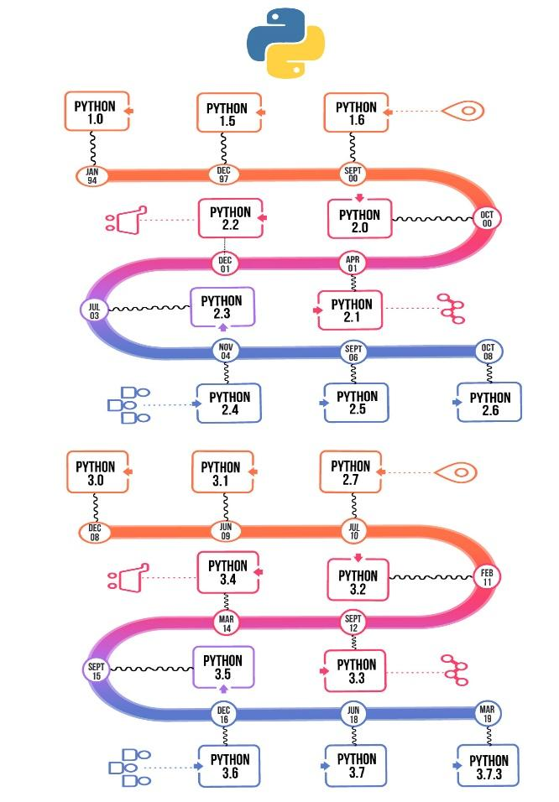

**Necessity of Python:**

Python is a high-level, interpreted, interactive and object-oriented scripting language. Python is designed to be highly readable. It uses English keywords frequently where as other languages use punctuation, and it has fewer syntactical constructions than other languages. Python's features include −

* Easy-to-learn − Python has few keywords, simple structure, and a clearly defined syntax. This allows the student to pick up the language quickly.
* Easy-to-read − Python code is more clearly defined and visible to the eyes.
* Easy-to-maintain − Python's source code is fairly easy-to-maintain.
* A broad standard library − Python's bulk of the library is very portable and cross-platform compatible on UNIX, Windows, and Macintosh.
* Interactive Mode − Python has support for an interactive mode which allows interactive testing and debugging of snippets of code.
* Portable − Python can run on a wide variety of hardware platforms and has the same interface on all platforms.
* Extendable − You can add low-level modules to the Python interpreter. These modules enable programmers to add to or customize their tools to be more efficient.
* Databases − Python provides interfaces to all major commercial databases.
* GUI Programming − Python supports GUI applications that can be created and ported to many system calls, libraries and windows systems, such as Windows MFC, Macintosh, and the X Window system of Unix.
* Scalable − Python provides a better structure and support for large programs than shell scripting.

Apart from the above-mentioned features, Python has a big list of good features, few are listed below −

* It supports functional and structured programming methods as well as OOP.
* It can be used as a scripting language or can be compiled to byte-code for building large applications.
* It provides very high-level dynamic data types and supports dynamic type checking.
* It supports automatic garbage collection.
* It can be easily integrated with C, C++, COM, ActiveX, CORBA, and Java.

**Installation Guide of Python:**

In this section, we’ll see how to check which version of Python, if any, is installed on your Windows computer, and if not how to install it in your windows machine

Check Your Python Version on Windows:

To check if you already have Python on your Windows machine, first open a command-line application, such as PowerShell.

1. Press the Win (windows) key.

2. Type PowerShell.

3. Press Enter.

With the command line open, type in “python ---version” command and press Enter.

Using the --version switch will show you the version that’s installed. Alternatively, you can use the -V switch.

**How to Install from the Full Installer:**

For professional developers who need a full-featured Python development environment, installing from the full installer is the right choice. It offers more customization and control over the installation than installing from the Microsoft Store.

You can install from the full installer in two steps.

Step 1: Download the Full Installer

Follow these steps to download the full installer:

1.Open a browser window and navigate to the Python.org .

2.Under the “Python Releases for Windows” heading, click the link for the Latest Python 3 Release - Python 3.x.x. As of this writing, the latest version was Python 3.8.4.

3.Scroll to the bottom and select either Windows x86-64 executable installer for 64-bit or Windows x86 executable installer for 32-bit.

Step 2: Run the Installer

Once you’ve chosen and downloaded an installer, run it by double-clicking on the downloaded file. A dialog box like the one below will appear

There are four things to notice about this dialog box:

1. The default install path is in the App Data/ directory of the current Windows user.

2.The Customize installation button can be used to customize the installation location and which additional features get installed, including pip and IDLE.

3.The Install launcher for all users (recommended) checkbox is checked default. This means every user on the machine will have access to the py.exe launcher. You can uncheck this box to restrict Python to the current Windows user.

4.The Add Python 3.8 to PATH checkbox is unchecked by default. There are several reasons that you might not want Python on PATH, so make sure you understand the implications before you check this box.

The full installer gives you total control over the installation process.

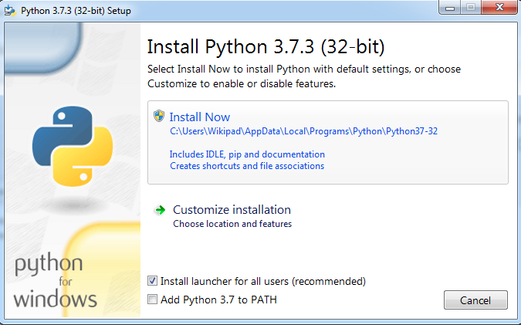

**How to Install Python on macOS:**

There are two installation methods on macOS:

1.The official installer

2.The Homebrew package manager

**How to Check Your Python Version on a Mac:**

To check which Python version, you have on your Mac, first open a command-line application, such as Terminal.

Press the Cmd+Space keys.

Type Terminal.

Press Enter

With the command line open, type in the following commands :

Python --version

Python2 --version

Pyhton3 --version

If you have Python on your system, then one or more of these commands should respond with a version number.

There are two ways to install the official Python distribution on macOS:

1. The official installer: This method involves downloading the official installer from the Python.org website and running it on your machine.

2. The Homebrew package manager: This method involves downloading and installing the Homebrew package manager if you don’t already have it installed, and then typing a command into a terminal application.

Both the official installer and the Homebrew package manager will work, but only the official installer is maintained by the Python Software Foundation.

**How to Install from the Official Installer:**

Installing Python from the official installer is the most reliable installation method on macOS. It includes all the system dependencies needed for developing applications with Python.

You can install from the official installer in two steps.

Step 1: Download the Official Installer

Follow these steps to download the full installer:

1. Open a browser window and navigate to the Python.org

2. Under the “Python Releases for Mac OS X” heading, click the link for the Latest Python 3 Release - Python 3.x.x. As of this writing, the latest version was Python 3.8.4.

3. Scroll to the bottom and click macOS 64-bit installer to start the download.

When the installer is finished downloading, move on to the next step.

Step 2: Run the Installer

Run the installer by double-clicking the downloaded file. You should see the following window

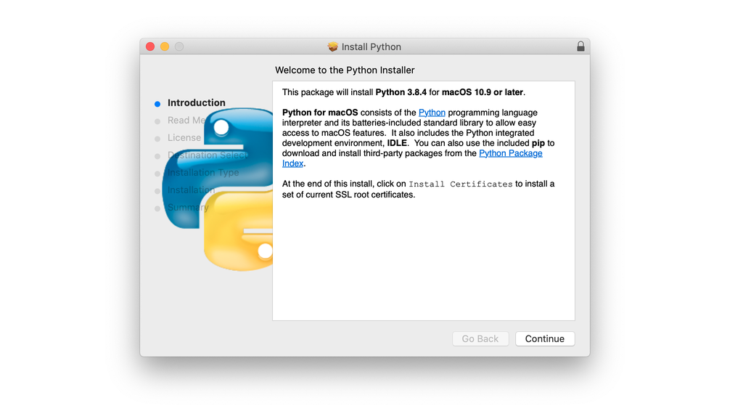

Follow these steps to complete the installation:

1.Press Continue a few times until you’re asked to agree to the software license agreement. Then click Agree.

2. You’ll be shown a window that tells you the install destination and how much space it will take. You most likely don’t want to change the default location, so go ahead and click Install to start the installation.

When the installer is finished copying files, click Close to close the installer window.